SATELLITE COVERAGE ANALYZER
Complete User & Technical Guide

Every feature, every dialog, and every plot in the application, together with the complete mathematical model underlying its geometry — illustrated throughout with screenshots of the running application and properly typeset equations rather than paraphrased descriptions.

1. Introduction & Launching the App 4
1.1 Requirements 4
1.2 Launching 5
2. Interface Overview 6
3. The Project Explorer Tree 8
3.1 Adding nodes 9
3.2 Deleting nodes 9
3.3 Renaming 10
3.4 Selecting 10
4. The Properties Panel 11
4.1 Satellite fields 11
4.2 Antenna fields 12
4.3 Polygon fields 13
4.4 City Point fields 14
5. Plot 1 — The 3-D Globe and the WGS-84 Earth Model 16
5.1 Interacting with Plot 1 16
5.2 What is drawn on Plot 1 16
5.3 Per-satellite camera memory 17
5.4 The mathematical model: why an ellipsoid instead of a sphere 17
6. Plot 2 — View From the Satellite, and the Projection Mathematics 20
6.1 The four projection grids 20
6.1.1 THE UNDERLYING FORMULAS 21
6.2 What else is always shown on Plot 2 22
7. Loading and Managing .grd Antenna Patterns 23
7.1 Three ways to load a file 23
7.2 The GRD Library manager 23
7.3 The standalone Pattern Viewer 24
7.4 Assigning a pattern to an antenna, and import orientation 25
8. Generate Contour -> Project onto Plot 2 27
9. Contour Levels & Colors 28
9.1 Row-by-row editing 29
9.2 Quick generate 30
9.3 Where this dialog is opened from 30
10. Polarization 31
10.1 What co-pol and cross-pol actually mean for a given file 31
10.2 Switching views 31
10.3 Ratio modes and Normalization 33
10.4 Independent levels/colors per Polarization mode 33
11. Normalization & Peak (dB) 35
12. Adjust Boresight 38
13. Peak Number Markers 40
14. City Points 42
15. Footprint Polygons 44
16. Axis Range (Plot 2) 45
17. The Tabs Strip 47
18. Exporting Results 48
18.1 Export Contour Coordinates (.xlsx) — bottom bar 48
18.1.1 THE RAY/ELLIPSOID INTERSECTION MATHEMATICS 48
18.2 Export Power Level at Cities (.xlsx) — left panel 49
18.3 Export Power Level at Polygon Vertices (.xlsx) — left panel 49
19. Appendix — Full Right-Click Menu Reference 51
19.1 Root ("untitled") 51
19.2 Satellite 51
19.3 Antenna 51
19.4 Polygon / City Point 51
19.5 Plot 2 (right-click the plot itself) 51

1. Introduction & Launching the App
Satellite Coverage Analyzer is a MATLAB application, built entirely on the uifigure graphics system rather than the older App Designer framework or classic figure windows, whose purpose is to let a satellite communications engineer visualize exactly where a given antenna's radiated energy actually lands on the surface of the Earth. The workflow the app is built around is deliberately simple to describe even though the geometry underneath it is not: you build a small project tree consisting of one or more Satellites, each carrying one or more Antennas, and each Antenna in turn carrying zero or more footprint Polygons and City Points that mark locations of interest. You then take a real, measured or simulated antenna gain pattern — stored in the industry-standard GRASP/TICRA ".grd" file format — and assign it to a specific Antenna in that tree. From that point forward, the app continuously re-projects that antenna's gain contours both onto a true three-dimensional model of the Earth and onto a flat, two-dimensional "view from the satellite" panel, so you can see precisely which countries, states, or specific cities fall inside a given dB contour, and precisely where the pattern's peak, its sidelobes, and its cross-polarization leakage actually point.
Unlike many desktop engineering tools, this application intentionally keeps its entire state in memory for the duration of one MATLAB session rather than maintaining an on-disk project file format of its own. There is no "File -> Save Project" menu item and no proprietary file extension to manage; instead, everything you build in the Project Explorer tree lives only as long as the MATLAB process itself is running, and the way you get your work OUT of the application is through the three dedicated Excel export functions covered in Section 18 of this guide. This design choice keeps the internal data model radically simple — a handful of nested MATLAB containers.Map objects, described in full in Section 3 — at the cost of requiring you to export what you need before closing MATLAB or clearing the workspace. Keep that trade-off in mind as you work: build your Satellite, Antenna, Polygon, and City structure, assign and tune your antenna pattern, and export your coordinates and power levels to .xlsx well before you consider the session finished.

1.1 Requirements
- MATLAB (developed and tested on a recent release; the app relies on uifigure, containers.Map, standard 2-D/3-D plotting, and Excel table export — no additional paid toolbox beyond base MATLAB is required to run it end to end).
- The two bundled shapefiles (World_Countries.shp for country outlines and Admin2.shp for India's internal state and union-territory boundaries) sitting alongside the main script, plus whichever .grd antenna pattern file(s) you intend to load and analyze.

1.2 Launching
Open SatelliteCoverageAnalyzer.m directly in MATLAB and run it — do not attempt to run any of the individual function files that live inside its subfolders, since those are local functions meant to be called by the main script and by each other, not launched on their own. The very first thing the script does is call addpath(genpath(...)) on its own containing folder, which recursively adds every subfolder next to it onto the MATLAB path for the remainder of the session. That single line is what lets a function living in, say, the grd/ folder freely call another function living in the geometry/ or render/ folder by name, with no explicit import statements anywhere in the codebase — MATLAB simply resolves each function call against whatever is currently on the path. After that, the script loads both boundary shapefiles, builds the in-memory project-state structure described in Section 3, constructs every visible UI component, and finally seeds one starter Satellite together with one starter Antenna underneath it, purely so the application never opens to a completely empty, confusing blank tree.
Tip: because there is no save/load file format, treat every session as self-contained. Build your project, load and tune your antenna pattern(s), and use the three export buttons described in Section 18 to get your coordinates and power levels out to .xlsx well before you close MATLAB or clear the workspace — nothing you build in the tree survives past the end of the session on its own.

2. Interface Overview
Although the underlying geometry and antenna-pattern mathematics are genuinely sophisticated, the on-screen layout of the application is kept as flat and predictable as possible: everything you need is visible in one single window, with no hidden modes or multi-step wizards standing between you and the data. The window is divided into a narrow control column running down the left-hand side, and a much wider working area on the right that itself splits into the two main plots. A thin strip of tabs runs along the very bottom of the window, and a small "Tools" menu sits in the top-left corner for the one feature (the standalone .grd pattern viewer) that doesn't require any project tree context at all. Every one of these regions is described individually below, and the screenshot underneath this paragraph is the actual running application on first launch, not a mockup — you are looking at exactly what you would see if you ran the script yourself right now.
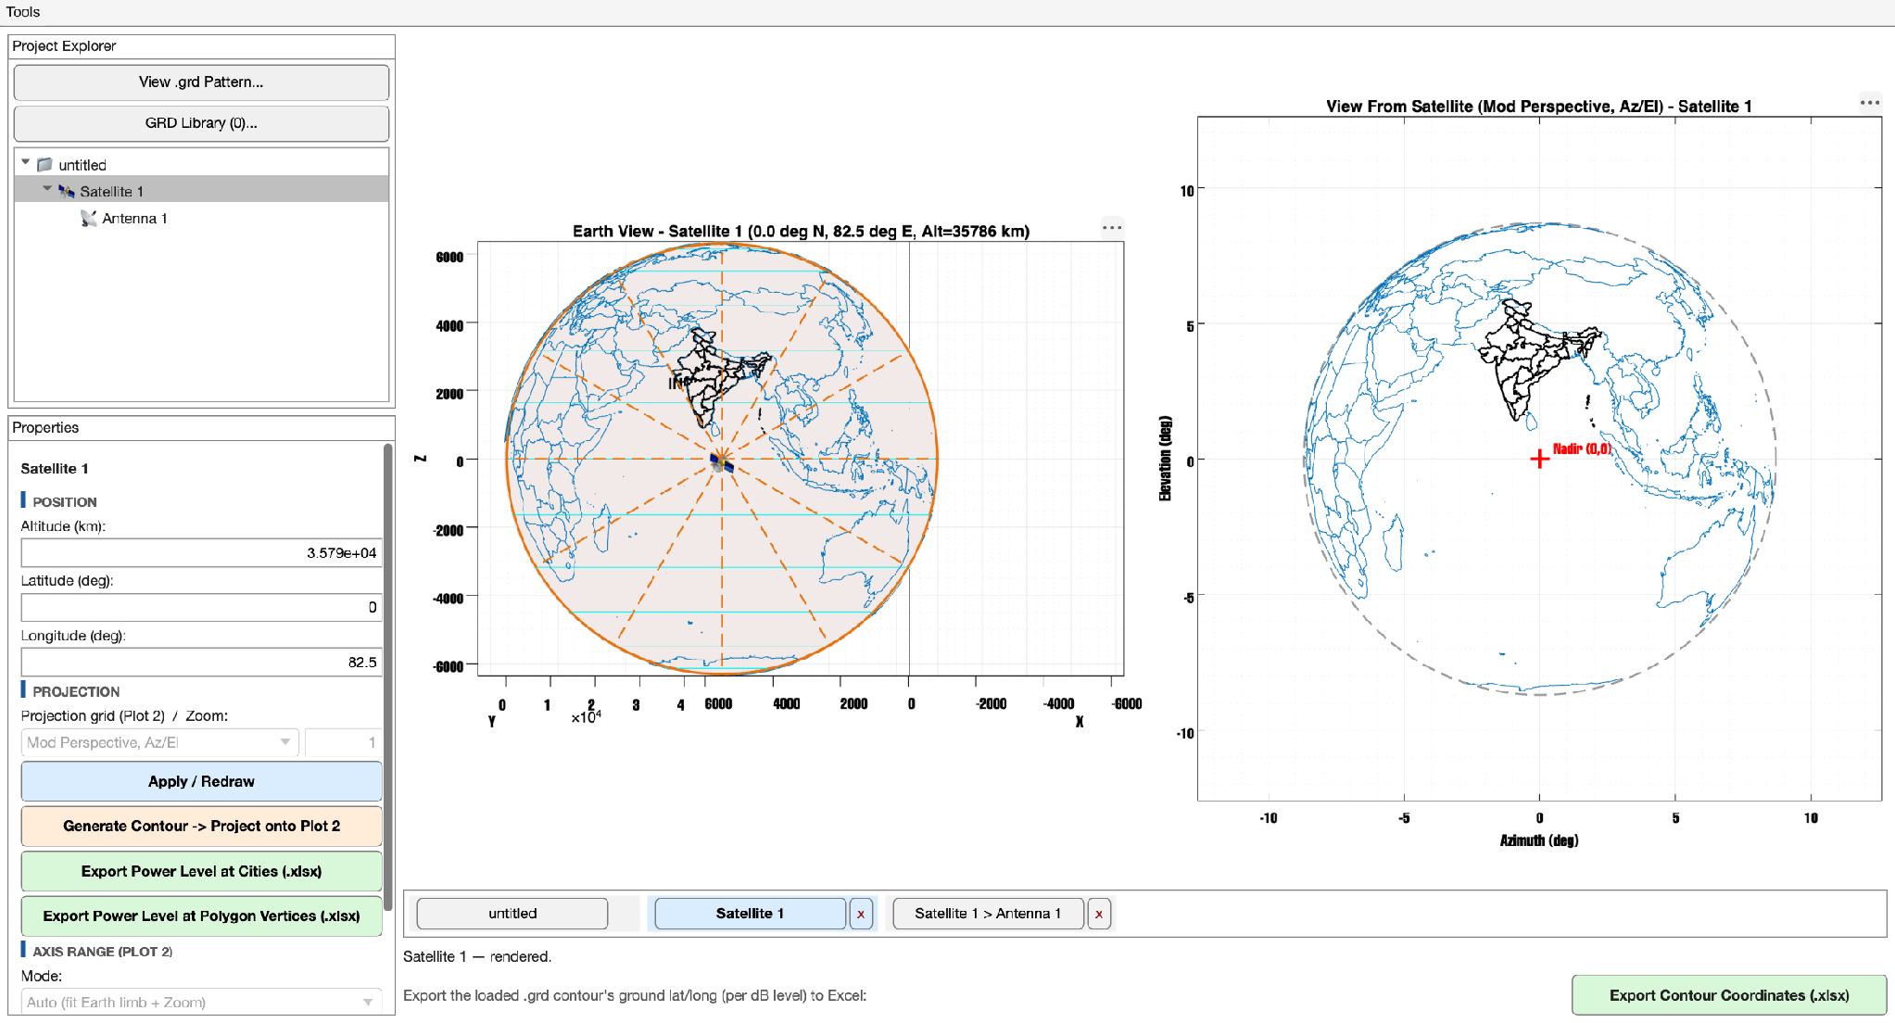
The app on first launch — every numbered region below is visible here.
Region | What it is
Project Explorer (top-left) | The project tree: Satellite -> Antenna -> Polygon/City. Click any node to select it; right-click for that node's context menu, covered in full in the Appendix (Section 19).
Properties panel (bottom-left) | Shows and edits whatever is currently selected in the tree above it — a completely different set of fields for a Satellite than for an Antenna, a Polygon, or a City Point, detailed field-by-field in Section 4.
Plot 1 (center) | The real 3-D WGS-84 Earth, always viewed from a fixed nadir angle relative to the selected satellite. Freely rotate/zoom it with the mouse (panning is intentionally disabled — see Section 5.1 for why).
Plot 2 (right) | The flat "view from the satellite." This is where a .grd antenna pattern's gain contours are actually drawn, measured, and read off, in whichever of four projection grids you choose (Section 6).
Tabs strip (bottom) | One tab per tree node you have visited so far this session — click a tab to jump straight back to it without re-navigating the tree, or click its "x" to close it (Section 17).
Left-panel buttons | "View .grd Pattern...", "GRD Library...", "Apply/Redraw", "Generate Contour", the two power-level exports, and the Axis Range section — see Sections 7, 8, 16, and 18.
Bottom bar | "Export Contour Coordinates (.xlsx)" — the real 3-D ray-cast export, and the most mathematically involved of the three exports (Section 18.1).

3. The Project Explorer Tree
The tree enforces a strict, single, unambiguous hierarchy, and understanding that hierarchy is the key to understanding almost every other feature in the application. At the very top sits an implicit "untitled" root node, which exists purely as a place to hang Satellites off of and carries no editable properties of its own. Directly underneath the root, you may add any number of Satellite nodes, each representing one physical or hypothetical spacecraft with its own orbital altitude, latitude, and longitude. Underneath each Satellite, you may add any number of Antenna nodes — a single satellite bus frequently carries several distinct antennas or beams, each pointed differently and each potentially carrying a completely different gain pattern, so the tree lets every Antenna maintain its own independent copy of essentially everything: its own position (seeded from its parent Satellite's position at creation time but fully independent from that moment forward), its own assigned pattern file, its own Polarization selection, its own contour levels and colors for all four Polarization views, its own Normalization and Peak (dB) setting, its own Zoom and Axis Range for Plot 2, and its own pointing offsets. Finally, underneath each Antenna, you may add any number of footprint Polygons (closed lat/lon boundaries representing, for example, a licensed service area) and City Points (single lat/lon locations representing, for example, a specific ground station or major population center you want to check coverage at). Nothing in the tree is ever allowed to skip a level: a Polygon or City Point always belongs to exactly one Antenna, and an Antenna always belongs to exactly one Satellite, which is precisely what lets the Properties panel and both plots always unambiguously know whose settings to show.
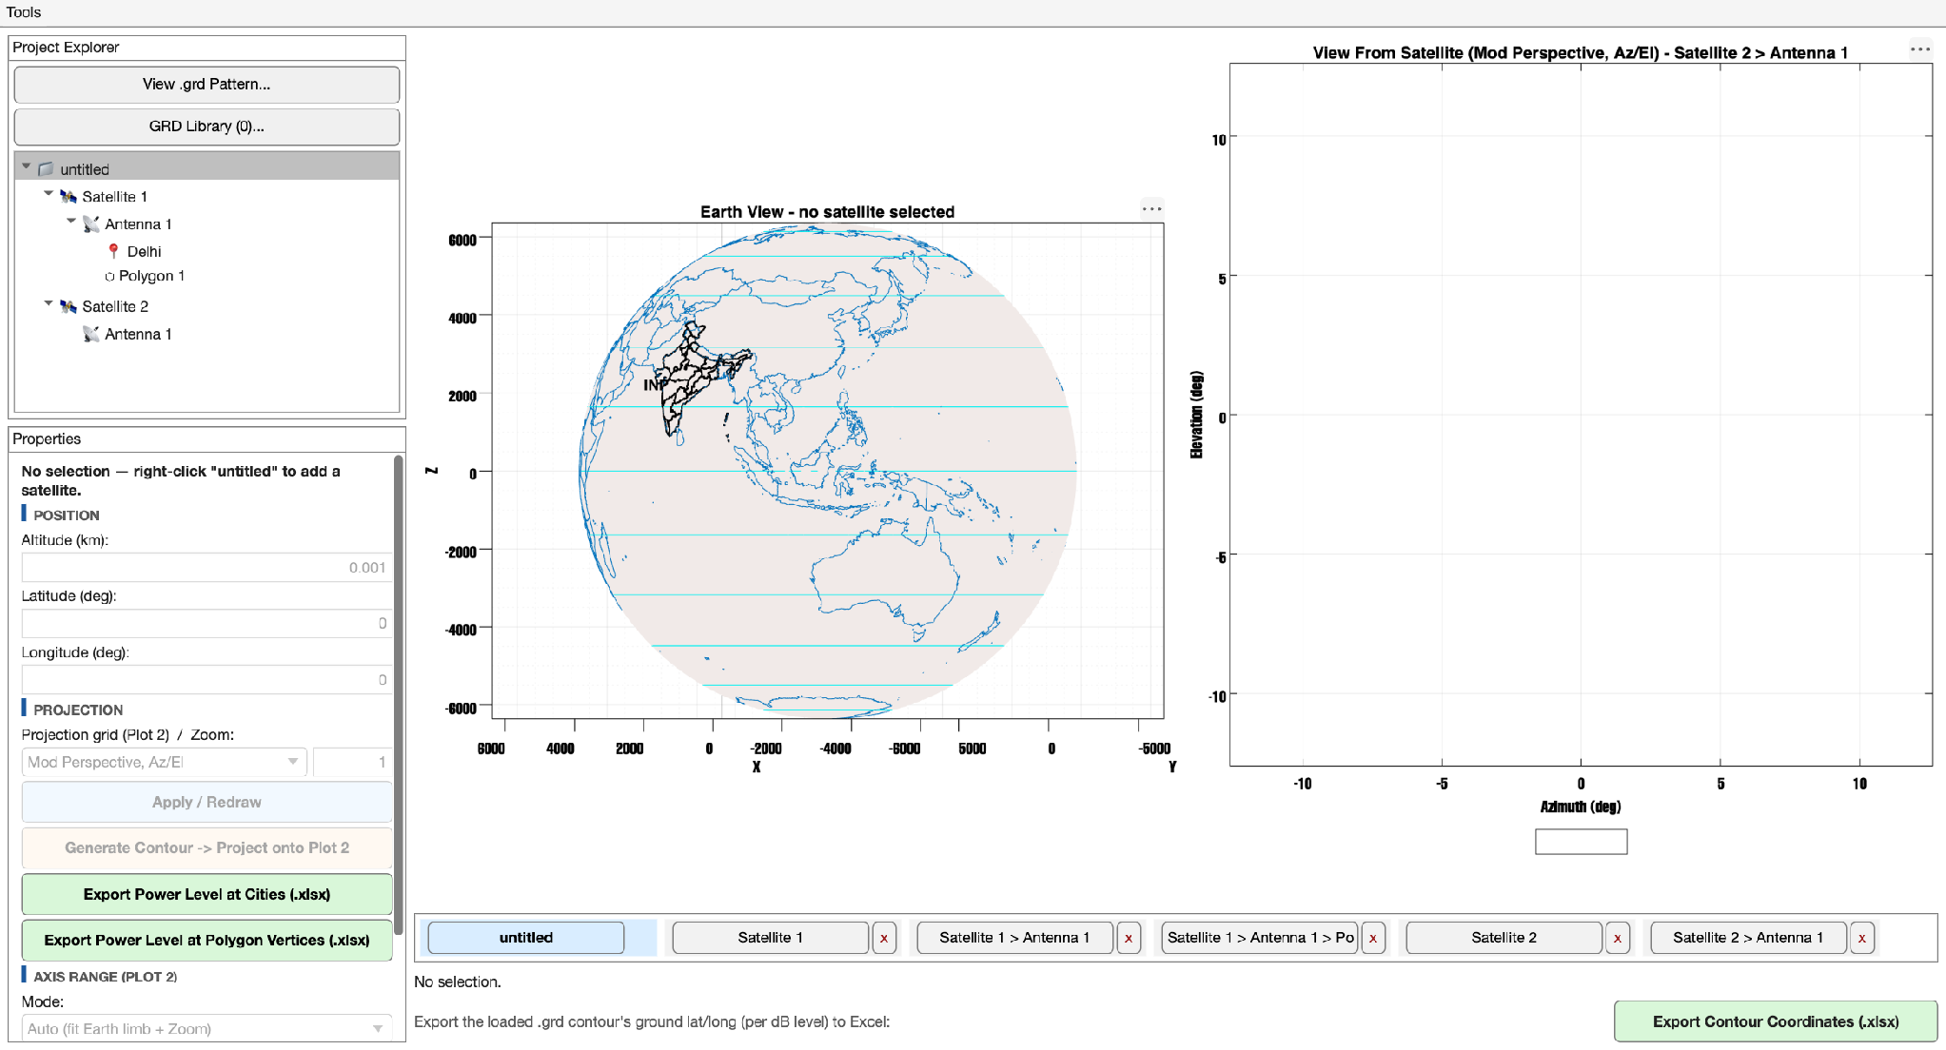
A more realistic project: two Satellites, each with its own Antenna, one carrying a City Point and a footprint Polygon — the full hierarchy described above, as it actually appears in the tree.

3.1 Adding nodes
Every addition in the tree happens through a right-click context menu attached to the PARENT you want the new node to live under — there is no separate "Add..." toolbar button anywhere in the application, which keeps the UI surface small and keeps the action of adding something visually and conceptually tied to exactly where in the hierarchy it will end up. Right-click the root "untitled" node to add a brand-new Satellite; right-click any existing Satellite to add a new Antenna underneath it; and right-click any existing Antenna to add either a new footprint Polygon, a new City Point typed in by hand, or a new City Point picked from a built-in list of Indian state capitals and other prominent cities (covered in full in Section 14). Newly created nodes are automatically selected the moment they are created, so you can immediately start editing their properties in the panel below without an extra click.
Right-click on... | Menu adds...
The root ("untitled") | New Satellite
A Satellite | New Antenna
An Antenna | New Polygon, New City Point, New City Point (From List)...
A Polygon or City | (no children — these are leaf nodes)

3.2 Deleting nodes
Right-clicking any node other than the root always offers a Delete option, and deleting a Satellite or an Antenna is a genuinely cascading operation — every Antenna underneath a deleted Satellite, and every Polygon and City underneath a deleted Antenna, is removed along with it, all behind a single confirmation prompt so you are never surprised by how much a single click actually removes. Beyond single-node deletion, the tree also supports Ctrl-click or Shift-click to build up a multi-selection spanning several Antennas, Polygons, and City Points at once (mixed types are perfectly fine within one selection), after which pressing the Delete or Backspace key removes every selected node in one confirmation instead of forcing you to right-click and confirm one at a time. Satellites are deliberately excluded from this multi-select bulk-delete path — because deleting a Satellite is already the single most destructive, cascading action available in the tree, it is kept to the slower, more deliberate one-at-a-time right-click flow on purpose, as a small safety rail against accidentally wiping out an entire spacecraft's worth of antennas in one keystroke.
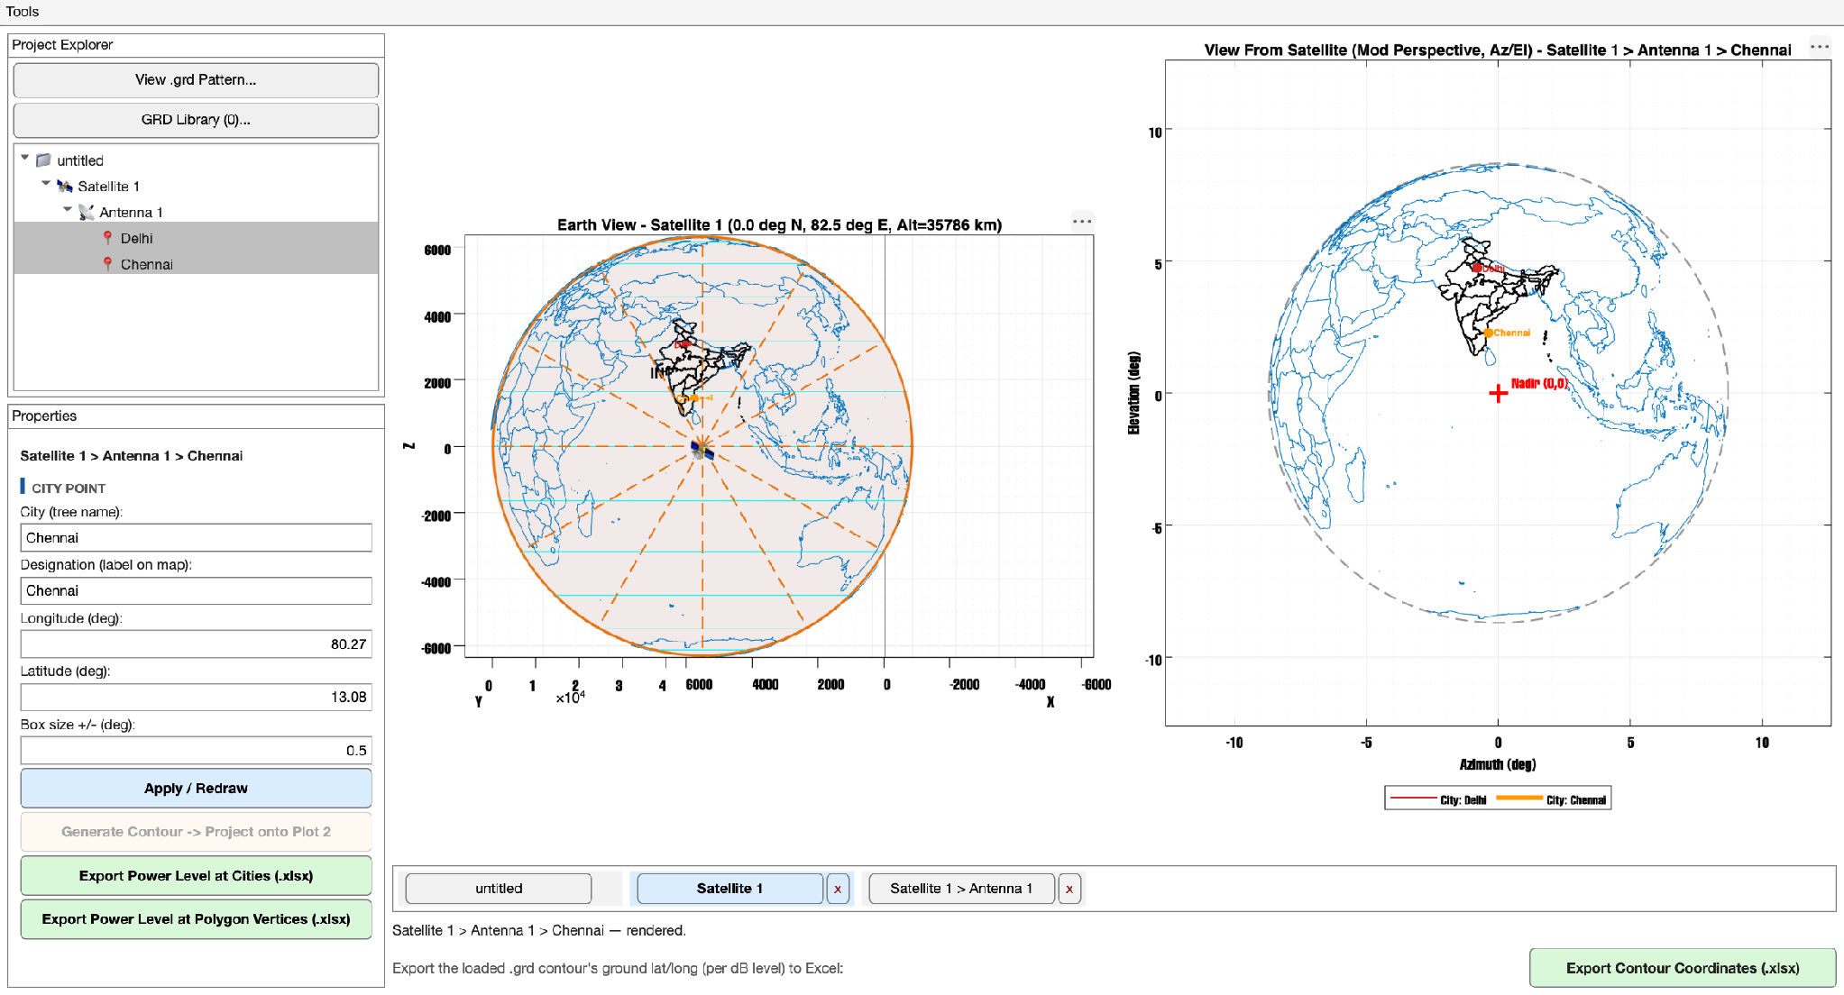
Two City Points, Delhi and Chennai, both Ctrl-clicked into a multi-selection — both rows highlighted in the tree, ready for a single Delete/Backspace to remove them together.

3.3 Renaming
Right-click any node for a "Rename..." option, which opens a small text-entry prompt for that node's tree label only. Renaming never touches position, pattern assignment, polarization, or any other setting — it is purely cosmetic, intended to let you replace a generic default label like "Antenna 1" with something more meaningful to your project, such as "East Beam" or "Ka-band Spot 3", without affecting how that antenna behaves in either plot or in any export.

3.4 Selecting
A single left-click on any node makes it the active selection, and that selection is what both the Properties panel and Plot 2 key off of. Selecting an Antenna, one of its Polygons, or one of its City Points all draw the exact same underlying Antenna's Plot 2 view — a Polygon or City does not own a separate view of its own, it simply causes that shared Antenna view to highlight the specific Polygon or City you clicked, which is a deliberate simplification that keeps Plot 2's framing, zoom, and polarization state consistent no matter which of an Antenna's children you happen to be looking at.

4. The Properties Panel
Whatever single node is currently selected in the tree, the Properties panel directly below it re-populates to show that node's own set of editable fields, and only that node's fields — there is no "global settings" area anywhere in the application, which is a deliberate consequence of the per-antenna ownership philosophy described in Section 3. Every numeric or dropdown field you see follows the same interaction pattern throughout the whole application: typing a new value into a text field, or picking a new value from a dropdown, only updates that field's in-memory staged value, and does NOT immediately redraw either plot or take effect anywhere else. You must click the corresponding "Apply / Redraw" button (Satellites and Antennas share one Apply button at the bottom of their respective field groups; Polygons and City Points each have their own dedicated Apply button) to actually commit the change and trigger a redraw of both Plot 1 and Plot 2. This two-step "type, then Apply" pattern is intentional: it lets you correct a typo or reconsider a value before it has any visible effect, rather than redrawing the (potentially expensive) globe and contour views on every single keystroke.

4.1 Satellite fields
Field | Meaning
Altitude (km) | Orbital altitude above the WGS-84 ellipsoid surface. Defaults to 35786 km, the standard geostationary altitude, but any positive value is accepted for LEO/MEO scenarios.
Latitude (deg) | Sub-satellite latitude — the geodetic latitude of the point directly beneath the satellite.
Longitude (deg) | Sub-satellite longitude. The default starter Satellite created at launch loads at 82.5 deg East, a commonly used Indian-subcontinent-facing geostationary slot, rather than at the equator/prime-meridian origin.
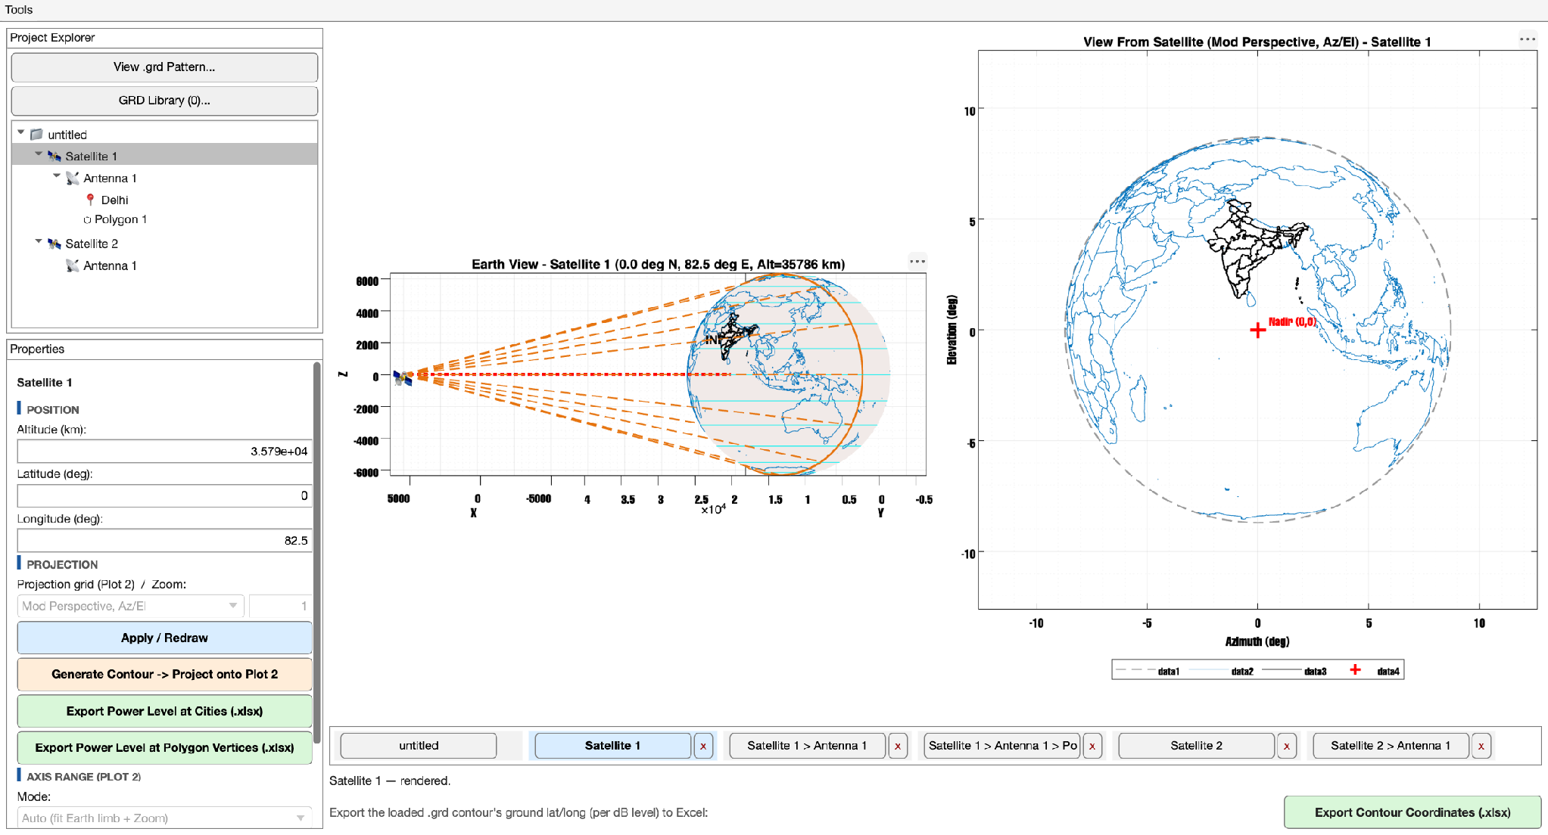
Satellite 1 selected directly (not one of its Antennas) — the Properties panel switches to the shorter Satellite field group, and Plot 2 shows only the nadir marker with no antenna pattern.

4.2 Antenna fields
An Antenna is seeded with its parent Satellite's current Altitude, Latitude, and Longitude at the moment it is created, purely as a sensible starting point — from that instant onward it is completely independent, and editing an Antenna's position never moves its Satellite, and editing the Satellite never drags any of its Antennas along with it. This independence extends to every other Antenna-level setting as well: Zoom, Projection grid, Polarization, contour levels/colors for all four polarization views, Normalization, Peak (dB), pointing offsets, and Axis Range are all stored per-Antenna, so two Antennas under the same Satellite, or even two Antennas assigned the exact same underlying .grd file, can be tuned to look completely different from one another with no risk of one antenna's edits leaking into another's.
Field | Meaning
Altitude / Latitude / Longitude (km / deg) | This antenna's own position — independent of its Satellite once set, exactly as described above.
Projection grid (Plot 2) | Which of the four projections detailed mathematically in Section 6.2 is used to draw Plot 2 for this specific antenna.
Zoom | A pure display-scale multiplier on Plot 2's automatic framing (values above 1 zoom in, values below 1 zoom out) — this never touches the underlying geometry, contour math, or any export.
Apply / Redraw | Commits any typed Altitude/Latitude/Longitude/Projection/Zoom changes and triggers a redraw of both plots.
Generate Contour -> Project onto Plot 2 | Re-derives this antenna's contour lines from whichever pattern is currently assigned to it (or, if none is assigned yet, grabs the most recently loaded pattern in the whole session and assigns it on the spot) — see Section 8.
Export Power Level at Cities (.xlsx) | Documented fully in Section 18.2.
Export Power Level at Polygon Vertices (.xlsx) | Documented fully in Section 18.3.
Axis Range (Plot 2) | Auto/Manual mode plus X/Y Start/End/Step fields — the exact same underlying setting as the "Set Axis Range..." popup covered in Section 16.
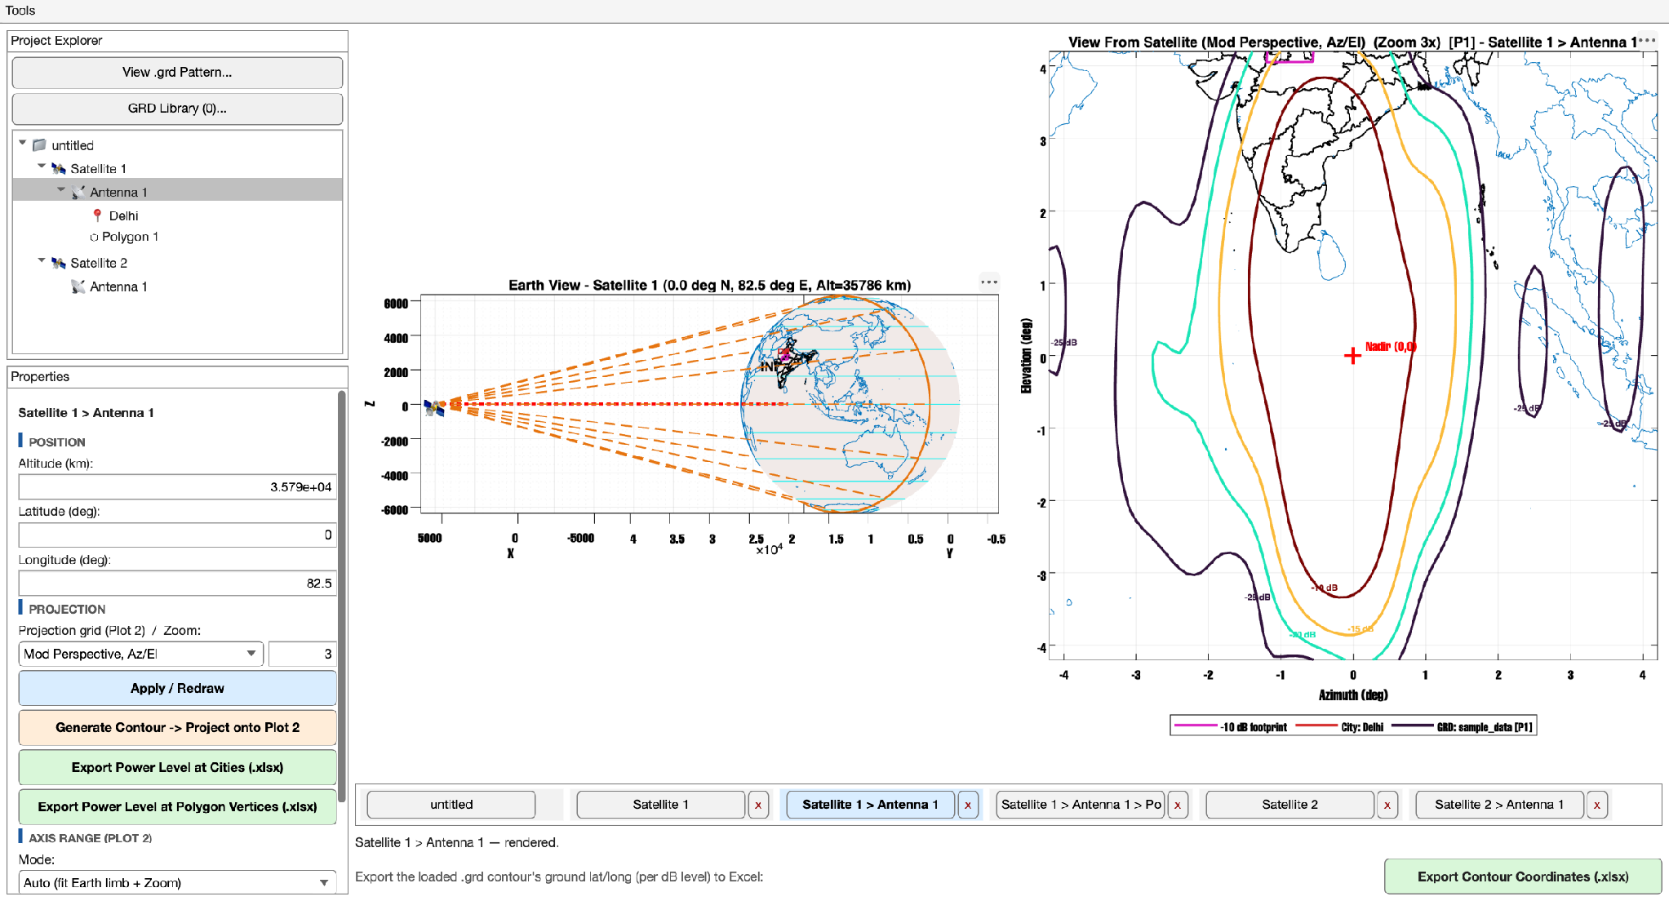
The same antenna with Zoom set to 3 — Plot 2's framing tightens around nadir accordingly; nothing about the underlying pattern data or geometry changes.

4.3 Polygon fields
A footprint Polygon's Properties panel is deliberately minimal: a Name field (used both for the tree label and, when it contains a recognizable dB value such as "-10 dB footprint", for automatic color-matching against the antenna's own contour colors), a multi-line vertex editor accepting one lat/lon pair per line, an Apply button, and a small live status readout confirming how many vertices were successfully parsed. There is no separate vertex-count limit and no requirement that the polygon be convex or even simple (non-self-intersecting) — whatever ordered list of lat/lon points you provide is drawn exactly as given on both Plot 1 and Plot 2.
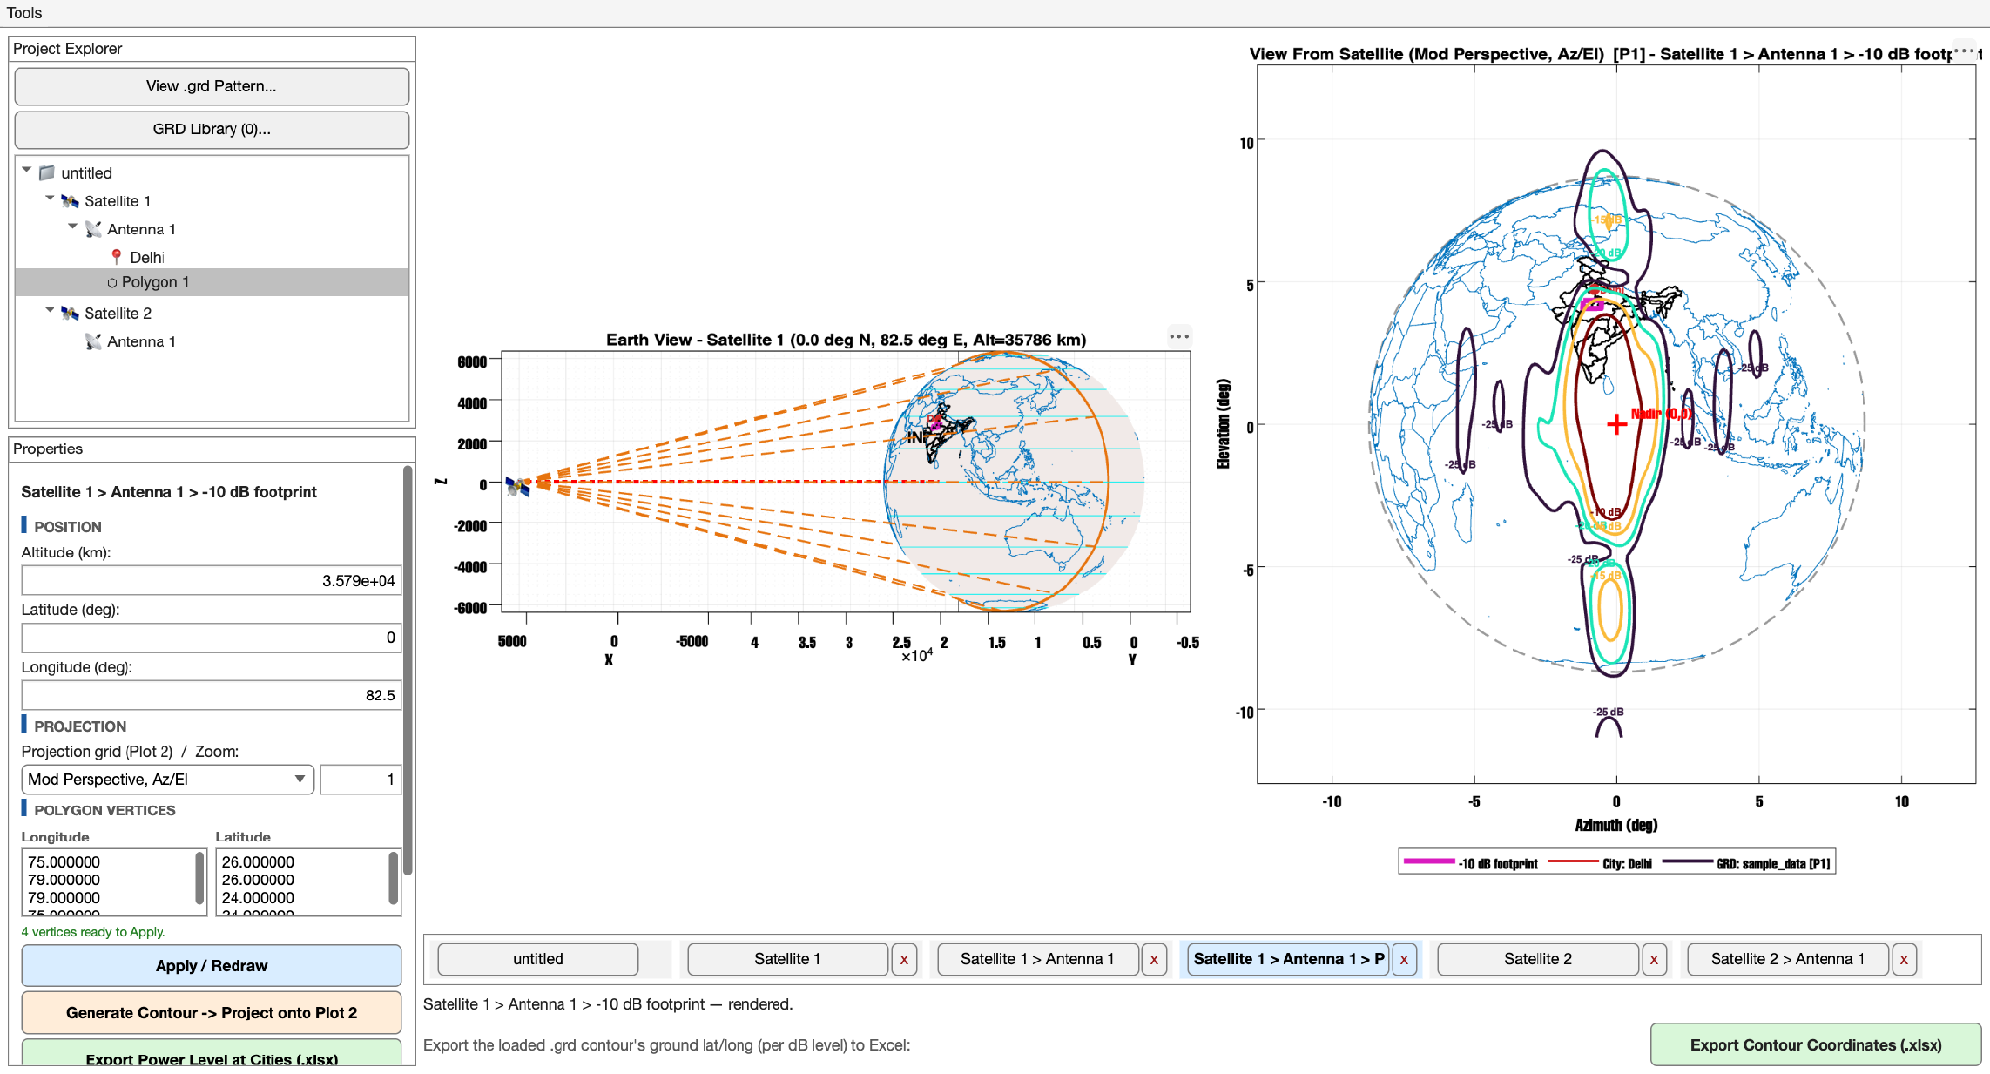
A footprint Polygon selected directly — the Properties panel shows its own Longitude/Latitude vertex-pair editor, distinct from every other node type's field group.

4.4 City Point fields
Field | Meaning
City (tree name) | The label shown for this node in the Project Explorer tree itself.
Designation (label on map) | The text label actually drawn next to the city marker on Plot 1 and Plot 2 — deliberately allowed to differ from the tree name, e.g. a short tree name like "GS1" paired with a longer on-map label like "Ground Station 1 (Primary)".
Longitude / Latitude (deg) | The city's real-world geodetic position, used identically by both plots and by the Power-Level export functions.
Box size +/- (deg) | Half-width, in degrees, of the small square marker box drawn on Plot 1 around the city — purely a Plot-1 visual aid with no effect on Plot 2 or on any export.
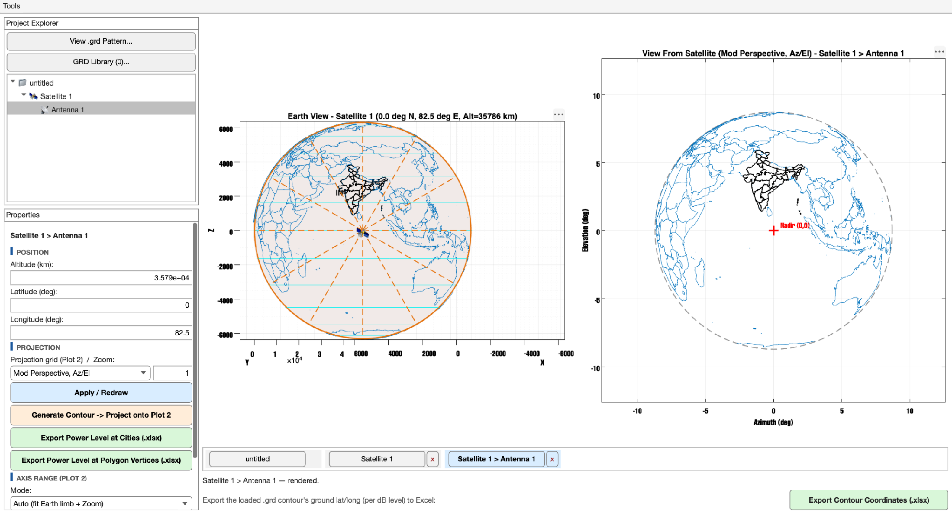
Antenna 1 selected — the Properties panel now reads "Satellite 1 > Antenna 1" and shows the antenna field group described above.

5. Plot 1 — The 3-D Globe and the WGS-84 Earth Model
Plot 1 is not a stylized or simplified globe — it is a genuine three-dimensional rendering of the WGS-84 reference ellipsoid, the same Earth-shape standard used by GPS and virtually every modern satellite geodesy system, always shown from a fixed nadir viewpoint relative to whichever Satellite or Antenna is currently selected. It is important to understand up front that Az/El/Rotation pointing adjustments (Section 12) never move anything you see on Plot 1 — those offsets exist purely to shift the pattern OVERLAY drawn on Plot 2, and Plot 1's job is instead to always show you the unambiguous, literal, physical truth of where the satellite sits relative to the Earth and which portion of the Earth's surface it can geometrically see at all, independent of how any one antenna aboard it happens to be pointed.

5.1 Interacting with Plot 1
- Rotate: click-drag anywhere on the globe to orbit the camera around it.
- Zoom: the scroll wheel, or the standard MATLAB axes zoom controls, move the camera closer to or farther from the globe.
- Pan: intentionally disabled on Plot 1. Panning a genuinely 3-D MATLAB axes is a known-flaky interaction that can freely translate the camera to a position INSIDE the Earth ellipsoid, especially after zooming in first — orbiting from a camera position inside the sphere then renders the inside surface of the globe, producing the disorienting "Earth looks cut open from the inside" visual bug. Rotate (which orbits around a fixed target at a fixed distance) and Zoom (which changes the camera's field of view rather than its position) simply do not have that failure mode, so Pan was removed from Plot 1's interaction set entirely as a permanent fix. Plot 2, being a flat 2-D view with no camera-inside-the-model risk at all, is completely unaffected and still supports normal panning.

5.2 What is drawn on Plot 1
- The satellite marker: a small satellite glyph placed at the satellite's true computed 3-D position, connected to the Earth's center by a thin dotted line for scale reference.
- The visibility cone: a set of dashed orange lines running from the satellite down to points along Earth's visible limb, together with a smooth limb outline, together illustrating the full disc of the Earth's surface that satellite can geometrically see at all, regardless of any one antenna's actual gain pattern.
- Ground footprint polygons: every footprint Polygon belonging to the currently selected Antenna, drawn at its true geodetic lat/lon position directly on the ellipsoid surface, color-coded to match its associated dB level where a level can be inferred from its name.
- City points: a small square marker box, a center dot, and a text label for every City Point belonging to the currently selected Antenna.

5.3 Per-satellite camera memory
Plot 1 independently remembers each Satellite's own last-used camera angle and zoom level for the remainder of the session. Rotate and zoom the globe while viewing Satellite 1, switch over to inspect Satellite 2, rotate that one to an entirely different angle, and then switch back to Satellite 1 — the camera snaps back to precisely the orientation you left it in, rather than resetting to a default nadir view every time you change selection. The very first time you ever view any given satellite in a session, before any camera state has been recorded for it, the camera instead homes automatically on that satellite's own nadir point, which is the sensible default starting orientation.
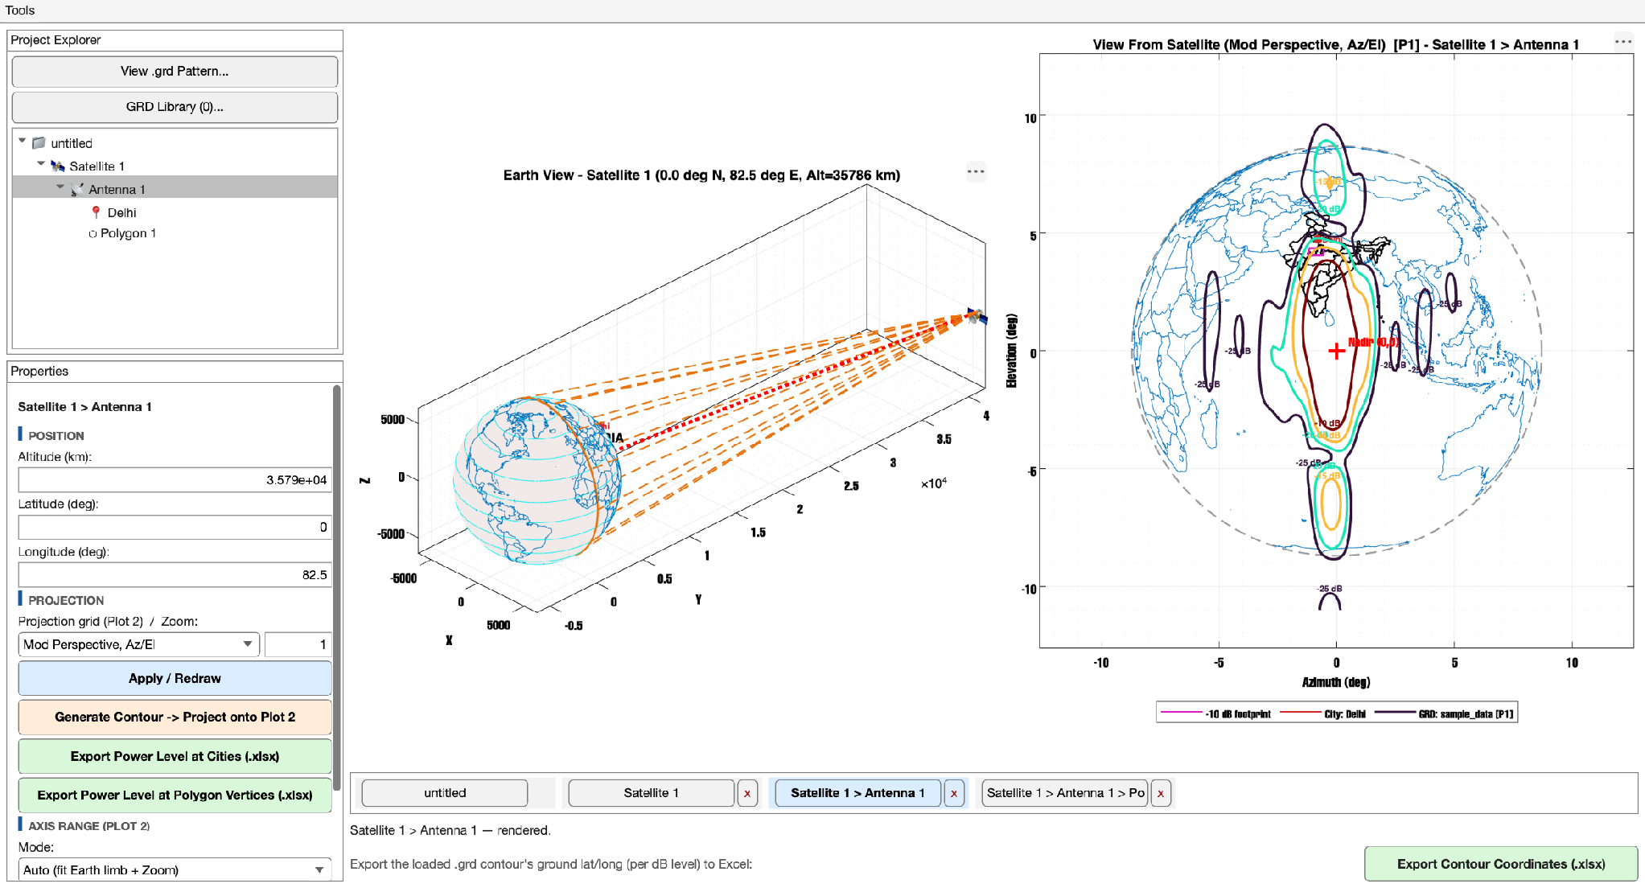
Plot 1 rotated to a custom viewing angle — MATLAB and the app together remember this exact orientation for the next time Satellite 1 is selected.

5.4 The mathematical model: why an ellipsoid instead of a sphere
Every single geometric calculation in this application ultimately reduces to one question, asked over and over for different points: given a latitude and longitude (and, for the satellite itself, an altitude), where is that point in three-dimensional space? The 3-D coordinate system used to answer that question throughout the app is called ECEF, short for Earth-Centered, Earth-Fixed — a simple (x, y, z) frame whose origin sits at the Earth's center, whose z-axis passes through the geographic North Pole, and whose x-axis passes through zero degrees longitude on the equator. The one remaining choice is what physical SHAPE to assume the Earth actually is when converting a lat/lon pair into that (x, y, z) frame, and this is where the WGS-84 ellipsoid comes in: rather than treating the Earth as a perfect sphere of one single radius everywhere (which is simple to compute but wrong by construction, since the real Earth bulges very slightly at the equator and flattens very slightly at the poles due to its own rotation), the app uses the true WGS-84 reference ellipsoid, defined by an equatorial radius of 6378.137 kilometers, a polar radius of 6356.7523 kilometers, and an eccentricity of 0.081819190842622. The gap between those two radii is only about 21.4 kilometers, roughly a third of one percent of the Earth's overall size — small enough to be visually imperceptible on the rendered globe, yet large enough, as Section 18.1 explains in detail, to matter for antenna-pattern accuracy at steep gain gradients.
$N(Φ) = \frac{Re}{\sqrt{1 − e^{2} \sin^{2}(Φ)}}$
N here is the so-called "prime-vertical radius of curvature" — a local radius value that changes slightly depending on how far north or south a given point sits, stretching that point outward a little more strongly near the equator than it does near the poles, which is precisely the geometric effect that produces the ellipsoid's bulge in the first place. Once N is known for a given latitude Φ, the full Cartesian ECEF position follows directly, with Λ standing for longitude and H standing for height above the ellipsoid surface — zero for absolutely everything that sits ON the ground (every city, every polygon vertex, every country and state outline point), and equal to the orbital altitude for the satellite or antenna position itself:
$x = (N + H)·cos(Φ)·cos(Λ)$
$y = (N + H)·cos(Φ)·sin(Λ)$
$z = (N·(1 − e^{2}) + H)·sin(Φ)$
This exact formula is implemented, essentially verbatim, in a single dedicated function, geometry/geodeticToECEF_wgs84.m, and every place in the codebase that needs to know where a lat/lon/height point sits in 3-D space — the globe mesh itself, every country and state boundary point, every City Point, every footprint Polygon vertex, and the satellite's own position — calls through that one function, with H set appropriately for whichever kind of point is being converted. Centralizing the math this way means there is exactly one place to verify for correctness, and that verification has in fact been carried out independently: the forward conversion was cross-checked against pymap3d, a well-established, independently authored geodesy library with no code in common with this project, across 216 test points including both poles, the antimeridian, and satellite altitudes ranging from low Earth orbit up through geostationary, and the maximum discrepancy found was 1.09x${10}^{-8}$ meters — eleven nanometers, which is floating-point noise rather than any genuine mathematical disagreement.

6. Plot 2 — View From the Satellite, and the Projection Mathematics
Where Plot 1 answers "where is everything, physically, in three dimensions," Plot 2 answers a different and more practically useful question for antenna work: "what does the view look like FROM the satellite, looking back down at the Earth and through this specific antenna's gain pattern?" It is a genuinely flat, two-dimensional projection — no camera to rotate, no risk of the pan-related rendering bug described in Section 5.1 — of everything the selected antenna can see, and it is where a .grd pattern's gain contours are actually drawn, measured, and read off. Critically, all four of the selectable projection grids described below sit on top of the exact same underlying WGS-84 geometry from Section 5.4; the projection choice only changes HOW a three-dimensional look-direction is flattened onto the two-dimensional page for display purposes, and never changes where that look-direction actually, physically points in three-dimensional space. Changing projection grids is therefore always a purely cosmetic choice, freely reversible and safe to experiment with, made per-Antenna via the Properties panel's "Projection grid (Plot 2)" dropdown described in Section 4.2.

6.1 The four projection grids
Grid | X axis | Y axis | Notes
uv | u = sin(θ)cos(φ) | v = sin(θ)sin(φ) | The rawest form — direct sine-projected coordinates, common in antenna-measurement software.
theta-phi | θ·cos(φ) | θ·sin(φ) | "Theta-space" — the radial scale is the off-boresight angle θ itself rather than its sine, so it stays linear even at large angles.
Az/El (default) | Azimuth (deg) | Elevation (deg) | The most commonly used view for satellite work; the Y axis is the polar axis.
El/Az | α (deg) | ε (deg) | The X axis is the polar axis instead of Y — the natural choice for antennas physically mounted on an Elevation-over-Azimuth gimbal.
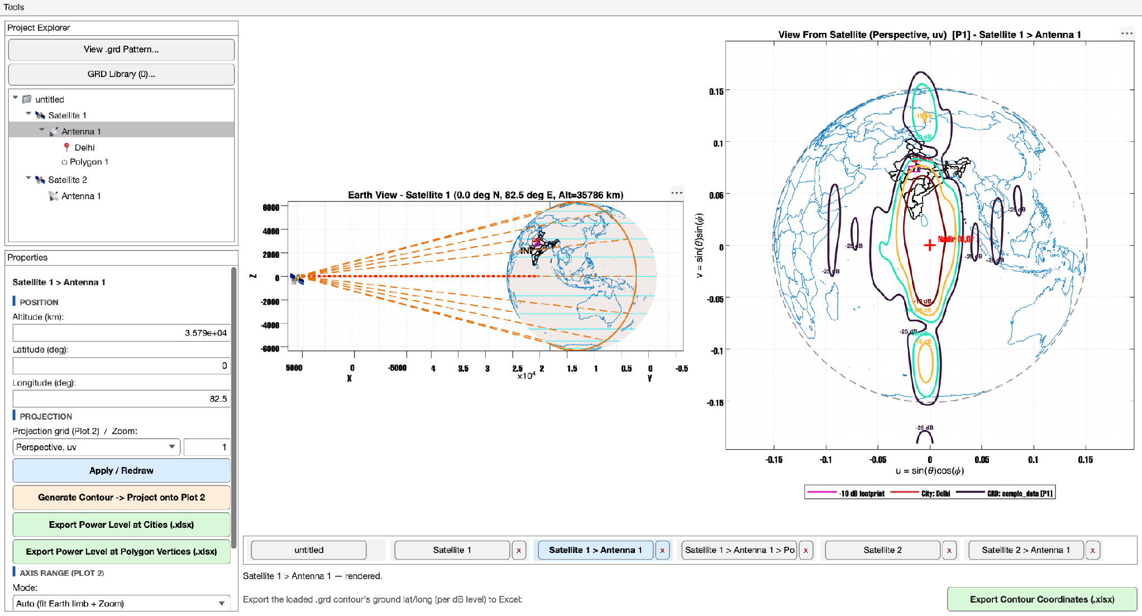
The same antenna and pattern, switched to the uv projection grid instead of the default Az/El — a different flattening of the identical underlying 3-D geometry.

6.1.1 THE UNDERLYING FORMULAS
Every point drawn on Plot 2 — whether it is a country-outline vertex, a City Point, a footprint-Polygon vertex, or a raw .grd pattern grid point — is first reduced to a unit look-direction vector (u, v, w) in the satellite's own local frame, where w is the component pointing back toward the satellite's own boresight/nadir direction. From that single shared (u, v, w) triple, each of the four grids above derives its own (X, Y) screen position using a small, closed-form formula, verified term-by-term against the SATSOFT antenna-analysis theory manual's own stated equations for exactly this purpose:
$Grid 1 (uv): X = u, Y = v$
$Grid 3 (Az/El): X = atan2(u, w), Y = asin(v)$
$Grid 4 (El/Az): X = asin(u), Y = atan2(v, w)$
These formulas live in one shared function, geometry/projectLookVector.m, and were round-tripped numerically as an additional independent check — projecting a large set of test angles forward through each formula, then inverting the SAME formula to recover the original angle, and comparing the two — with a worst-case discrepancy of roughly 1x${10}^{-15}$ at every tested angle, including angles as extreme as 89 degrees off boresight, where projection formulas are typically at their most numerically sensitive.

6.2 What else is always shown on Plot 2
- World country outlines and India state/UT outlines, projected from the selected antenna's real position exactly like every other point on the plot.
- A red "Nadir (0,0)" crosshair marking the direction straight down from the satellite.
- A dashed grey circle marking the Earth's limb at this antenna's own off-boresight half-angle — this circle is drawn as a mathematically constant angular radius by construction, so it will always appear as a perfect circle regardless of Earth's true ellipsoidal shape; it is a display aid for "how much of the sky is Earth," not a literal rendering of the Earth's true, slightly non-circular horizon as seen from orbit.
- Ground footprint Polygons and City Points, at their true projected positions.
- The assigned .grd pattern's gain contour, drawn in whichever Polarization view is currently selected — the full mathematics of which is covered in Section 10.
Zoom versus Axis Range: Zoom (Section 4.2) is a simple multiplier applied on top of Plot 2's automatically computed framing. Axis Range (Section 16) instead replaces that automatic framing entirely with typed X/Y limits of your own choosing. Both settings are purely cosmetic display choices, stored independently per Antenna, and neither one ever touches the underlying geometry, the contour-finding math, or any of the three .xlsx export functions described in Section 18.

7. Loading and Managing .grd Antenna Patterns
A .grd file, in the GRASP/TICRA format this application is built to read, stores an antenna's measured or simulated far-field gain pattern as a dense grid of complex field values sampled across a regular Azimuth/Elevation angular grid, typically covering some angular window around the antenna's intended boresight direction. Because a real .grd file can easily contain many tens of thousands of grid points and take a meaningful fraction of a second to parse, the application maintains a single session-wide "GRD Library," keyed internally by the file's own absolute path, so that opening the exact same file a second time — whether through a different menu entry point or for a different antenna entirely — simply reuses the already-parsed data instead of re-reading and re-parsing the file from disk again. This library is genuinely shared across the whole project: five different Antennas can all point at the very same parsed pattern entry, each with their own completely independent Polarization, levels, colors, Normalization, and Peak (dB) settings layered on top of that one shared copy of the raw data, exactly as described in Section 3.

7.1 Three ways to load a file
Entry point | What it does
"View .grd Pattern..." button (above the tree) | Prompts for a file, parses it into the library, and opens the standalone Pattern Viewer window (Section 7.3) — this entry point does not require any Satellite or Antenna to be selected at all.
"GRD Library..." button | Opens the GRD Library manager window (Section 7.2), listing every file loaded into the library so far this session.
Right-click Plot 2 -> "Add GRD..." | Requires an antenna to already be selected in the tree. Lets you pick an already-loaded pattern from a dropdown, OR browse for a brand-new file, together with that pattern's import orientation, and assigns the result directly to the currently selected antenna in one step.
Regardless of which of these three entry points you use, the very FIRST time any given file is loaded into the library, the Contour Levels & Colors popup described in Section 9 opens automatically, so that you can set that pattern's default dB contour levels, their colors, its Normalization mode, and its Peak (dB) value before anything is ever actually drawn with it. Loading the same file again later, from any entry point, never re-opens that popup automatically — your original choices are simply reused.

7.2 The GRD Library manager
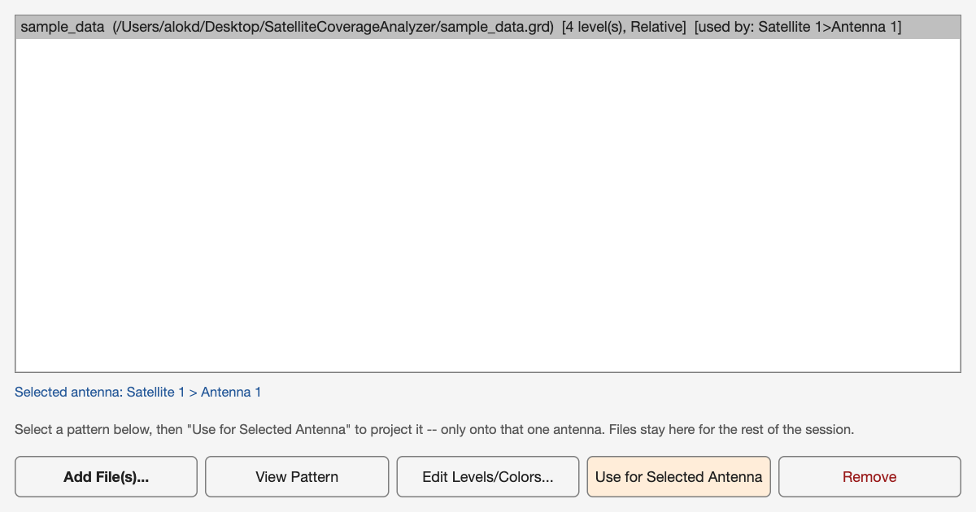
The GRD Library manager — one row per loaded file, showing its path, level count, Normalization mode, and which antenna(s) currently use it.
Along the bottom of this window sit five buttons: "Add File(s)..." lets you browse for and load one or more additional patterns (multi-selection in the file browser is fully supported); "View Pattern" opens the standalone Pattern Viewer, described next, for whichever row is currently selected; "Edit Levels/Colors..." reopens the Contour Levels & Colors popup for that file's shared LIBRARY-level default (this deliberately never retroactively changes any antenna's own already-cloned, independent copy of those settings — see Section 3 for why that independence matters); "Use for Selected Antenna" assigns the selected library row to whichever Antenna currently has focus in the Project Explorer tree; and "Remove" drops that file from the library entirely, simultaneously clearing it from every antenna that had it assigned, which is a genuinely destructive action worth pausing before confirming on a shared, heavily-used pattern.

7.3 The standalone Pattern Viewer
The Pattern Viewer shows a file's own native Azimuth/Elevation grid completely on its own terms — with no ground projection, no tie to any particular satellite or antenna position, and no Polarization selector, since it has no antenna context for a Polarization choice to even apply to. It always shows the P1, co-polarization view specifically. Its purpose is purely diagnostic: "let me actually look at the raw shape of this pattern file" before or independent of assigning it anywhere in the project tree.
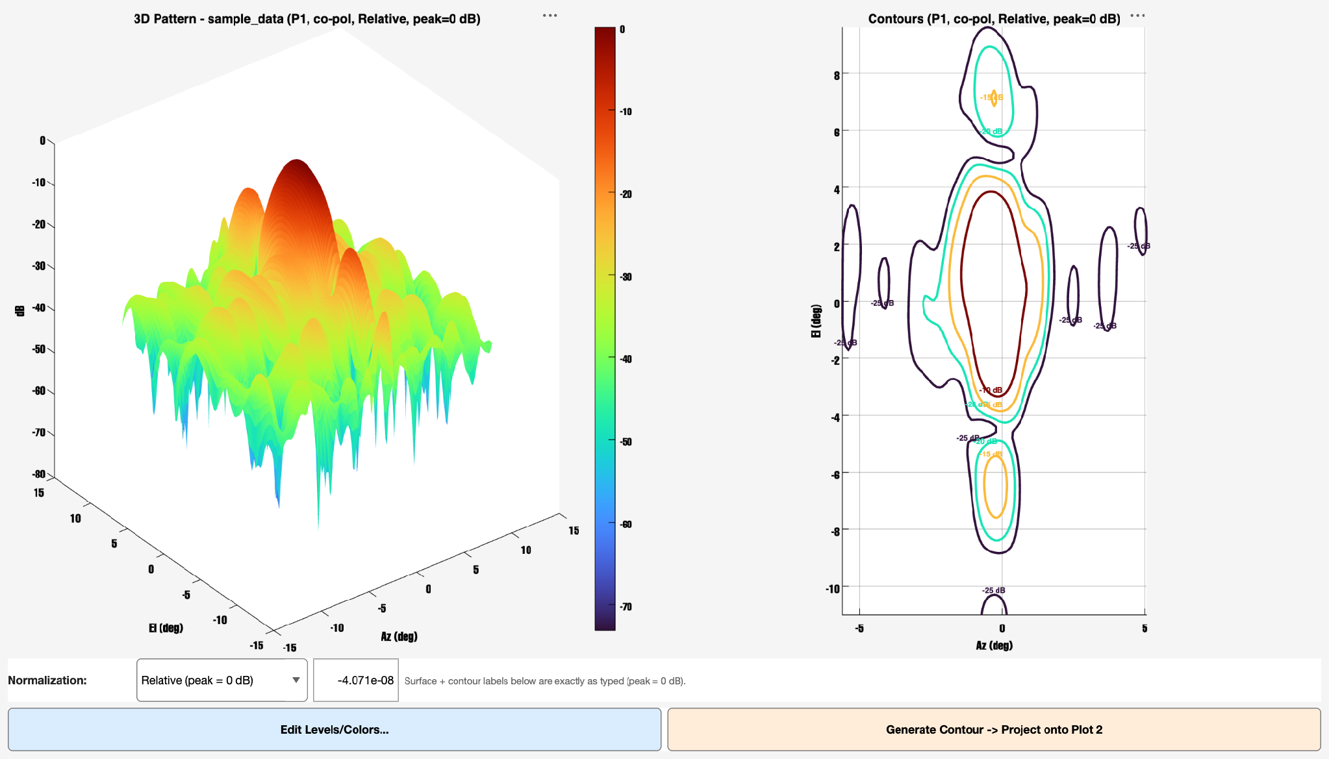
The standalone Pattern Viewer: a 3-D gain surface (left) and a matching 2-D contour plot (right), both responding live to the Normalization/Peak (dB) controls at the bottom of the window.

7.4 Assigning a pattern to an antenna, and import orientation
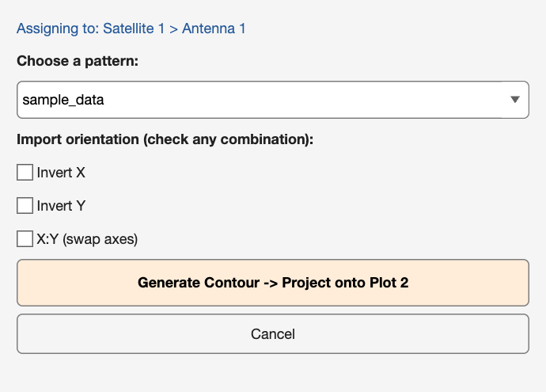
The "Add GRD..." popup — pick any already-loaded pattern (or browse for a new file), choose an import orientation, and assign it to the selected antenna in one step.
Import orientation is offered as three independent checkboxes — Invert X, Invert Y, and X:Y (swap axes) — and any combination of the three may be checked simultaneously; leaving all three unchecked is treated as "Auto," meaning no transform at all. When more than one box is checked, Invert X and Invert Y are always applied first (their relative order to each other never matters, since negating two independent axes commutes), and the X:Y swap is applied last, on top of whatever the inversions produced. It is important to understand that this orientation setting only ever affects how the pattern visually LANDS on Plot 2 (and, correspondingly, in the two Power-Level export functions, which deliberately mirror Plot 2's on-screen display) — it never re-parses or re-interprets the underlying file data itself.
To change JUST the orientation of a pattern that has already been assigned to an antenna, without re-picking the source file at all, right-click Plot 2 and choose "Change Orientation...":
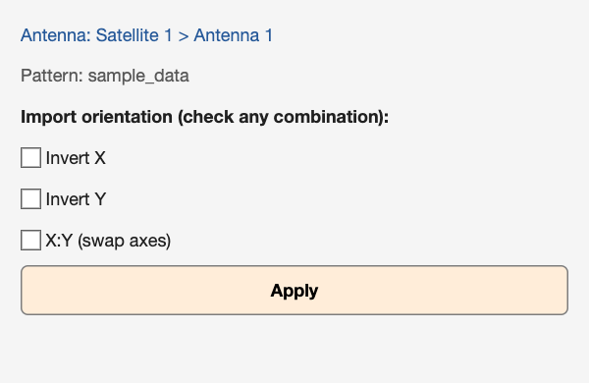
"Change Orientation..." — the same three checkboxes, focused specifically on a pattern that is already assigned.

8. Generate Contour -> Project onto Plot 2
This single left-panel button is the fastest, most direct path from "I have a pattern loaded somewhere in this session" to "I can actually see it drawn on my selected antenna's Plot 2." With an antenna selected in the tree, clicking it behaves in one of two ways depending on that antenna's current state. If the antenna already has a pattern assigned to it, the button simply re-derives that antenna's contour lines from scratch and refreshes both plots — genuinely useful after changing almost any setting that affects how the pattern is drawn, including Az/El/Rotation pointing offsets, Zoom, the selected Polarization view, Normalization mode, or Peak (dB) value, since none of those settings trigger an automatic redraw entirely on their own in every code path. If the antenna has NO pattern assigned yet, the button instead falls back to whichever .grd pattern was most recently opened or loaded anywhere in the current session — across any antenna, any window, any entry point — and assigns that pattern directly to the selected antenna on the spot. This fallback behavior is what makes the extremely common "browse to a file via View .grd Pattern..., then select an antenna, then click Generate Contour" workflow function smoothly end to end without ever having to make a separate trip through the GRD Library manager just to perform the assignment step.
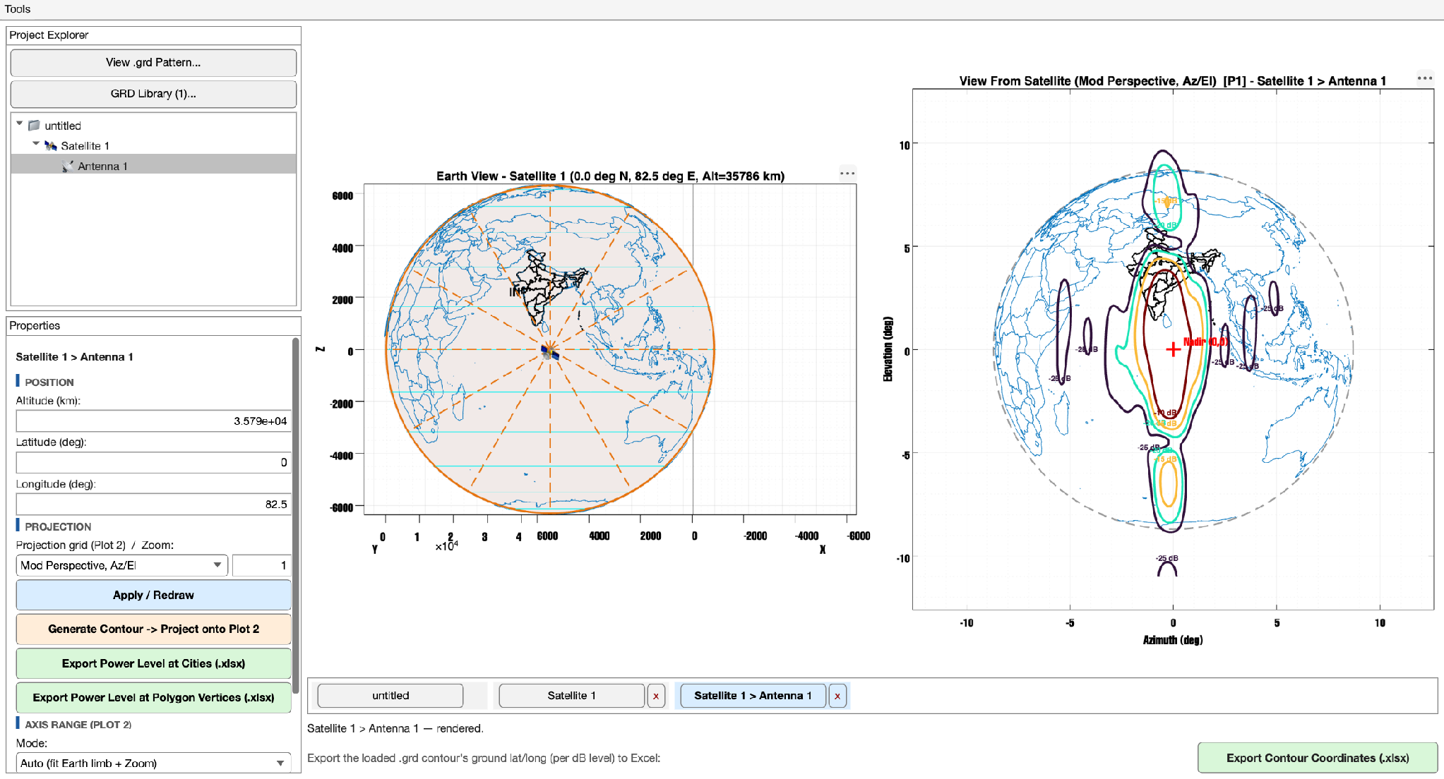
A pattern assigned and its contour drawn — the Plot 2 title now reads "[P1]", reflecting the currently-selected Polarization view described in Section 10.

9. Contour Levels & Colors
Every dB contour level plotted anywhere in the entire application — whether it is the GRD Library's own shared default for a freshly loaded file, or one specific Antenna's own fully independent instance for one specific Polarization view — is configured through this exact same popup dialog, reused across every entry point that needs it. The single most important rule to internalize about this dialog is that the number you type into the "dB Level" column is ALWAYS the offset from the pattern's own peak, with the peak itself defined as exactly 0 dB; this convention never changes regardless of Normalization mode, and it is precisely what gets matched against the pattern's underlying gain grid to actually find where a given contour line sits. The separate "Shown / Exported As" column immediately to its right is a live preview of what that typed offset actually turns into once Normalization and Peak (dB) are taken into account, letting you see both numbers side by side without needing to close the dialog and check the plot to understand the relationship between them.
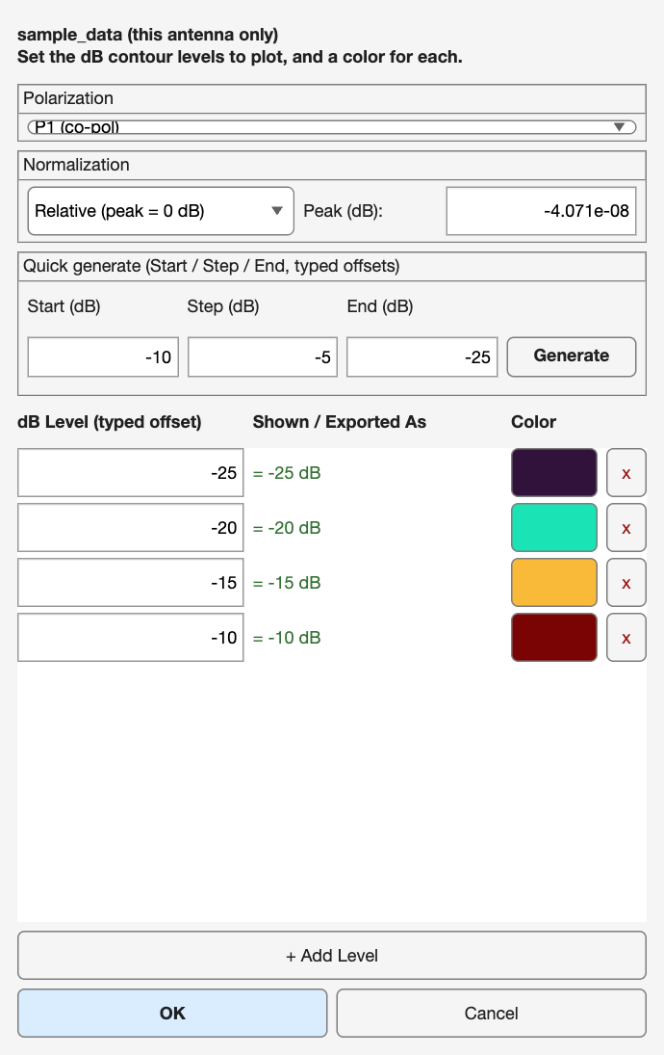
The Contour Levels & Colors editor, opened per-antenna (note the Polarization dropdown at the top, discussed further in Section 10.4).

9.1 Row-by-row editing
- dB Level: type any number here — always the typed OFFSET from the pattern's own peak, never an absolute value directly.
- Shown / Exported As: a read-only, live-updating preview of the actual label that will appear on the plot and in exports, computed from the current Normalization mode and Peak (dB) value.
- Color swatch: click to open the standard MATLAB color picker and assign any RGB color to that specific level.
- x button: removes just that one row from the table, leaving every other level untouched.

9.2 Quick generate
For the common case of wanting several evenly-spaced levels rather than hand-typing each one, type a Start value, a Step value, and an End value (for example -10, -5, and -25) into the small generator panel and click Generate — this immediately replaces the ENTIRE table with the resulting evenly-spaced range (in this example, -10, -15, -20, -25) and re-colors every row with a freshly generated rainbow colormap, giving you a clean, presentable starting point in a single click that you can then fine-tune row by row if needed.

9.3 Where this dialog is opened from
This exact dialog is reused across three different entry points, and which one you used determines what you are actually editing. Opening it from the GRD Library manager's "Edit Levels/Colors..." button, or from the standalone Pattern Viewer's own "Edit Levels/Colors..." button, both edit that file's shared LIBRARY default — always specifically the P1 co-polarization view, since the library has no single antenna context of its own. Opening it instead from Plot 2's right-click "Edit Levels/Colors (This Antenna)..." edits THIS specific antenna's own fully independent copy, covering all four Polarization modes at once, as described in Section 10.4.

10. Polarization
Right-clicking Plot 2 and choosing "Polarization" reveals four distinct views of the exact same underlying antenna measurement data, all four derived from the same two raw field-magnitude grids — the co-polarization magnitude, Eco, and the cross-polarization magnitude, Ecx — that are extracted once, at parse time, from the complex field values stored in the .grd file. Because all four views share this same underlying data, switching between them is instantaneous and never triggers any re-parsing of the source file; only the formula applied to the already-in-memory Eco and Ecx grids changes.
$P1 = 20·log(Eco) − peak, P2 = 20·log(Ecx) − peak$
$P1/P2 = 20·log(Eco / Ecx), P2/P1 = 20·log(Ecx / Eco)$
P1 is the co-polarization gain, defined so that its own peak always sits at exactly 0 dB — this is the antenna's main beam, the pattern most people mean when they informally say "the antenna pattern" without qualification. P2 is the cross-polarization gain, but critically referenced to the CO-polarization peak rather than to its own separate peak, which is the standard antenna-engineering convention for directly answering the practical question "how many dB down is the unwanted cross-pol leakage from the main beam's strongest point?" P1/P2 is the co/cross discrimination ratio, often called XPD in antenna literature, and unlike P1 and P2 it is already an absolute physical dB quantity in its own right rather than a value referenced to any peak, so it is never shifted by Normalization or Peak (dB) at all (Section 10.3). P2/P1 is simply its exact mirror image.

10.1 What co-pol and cross-pol actually mean for a given file
For files whose header field ICOMP equals 3 — the GRASP convention for "Ludwig-3" format — the .grd file itself directly and unambiguously defines which of its two stored field components is co-polarization and which is cross-polarization, and the application simply trusts that stated order without second-guessing it. For any other ICOMP value, most commonly ICOMP equal to 2, meaning the file stores circular RHCP/LHCP components instead, the file format itself does NOT self-label either component as "co" or "cross" — that distinction is a property of the specific antenna's design intent, not of the file format's own structure. For those files, the application auto-detects the co-polarization component as whichever of the two stored components reaches the higher peak magnitude anywhere across the entire grid, on the sound physical reasoning that the co-polarized component is, by definition, the one the antenna was actually designed to radiate, and should therefore dominate at its own peak compared to the unintentional cross-polarized leakage.

10.2 Switching views
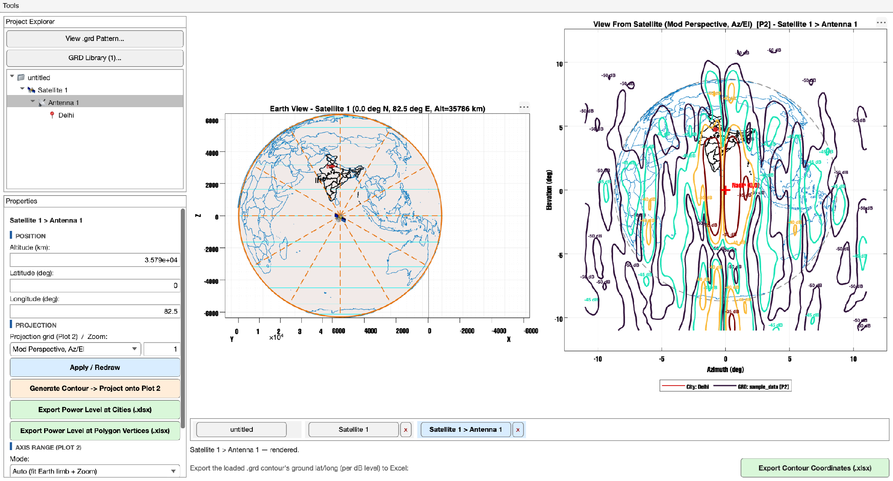
Switched to P2 — note the Plot 2 title now reads "[P2]" and the contour shape/levels are entirely different from the P1 view.
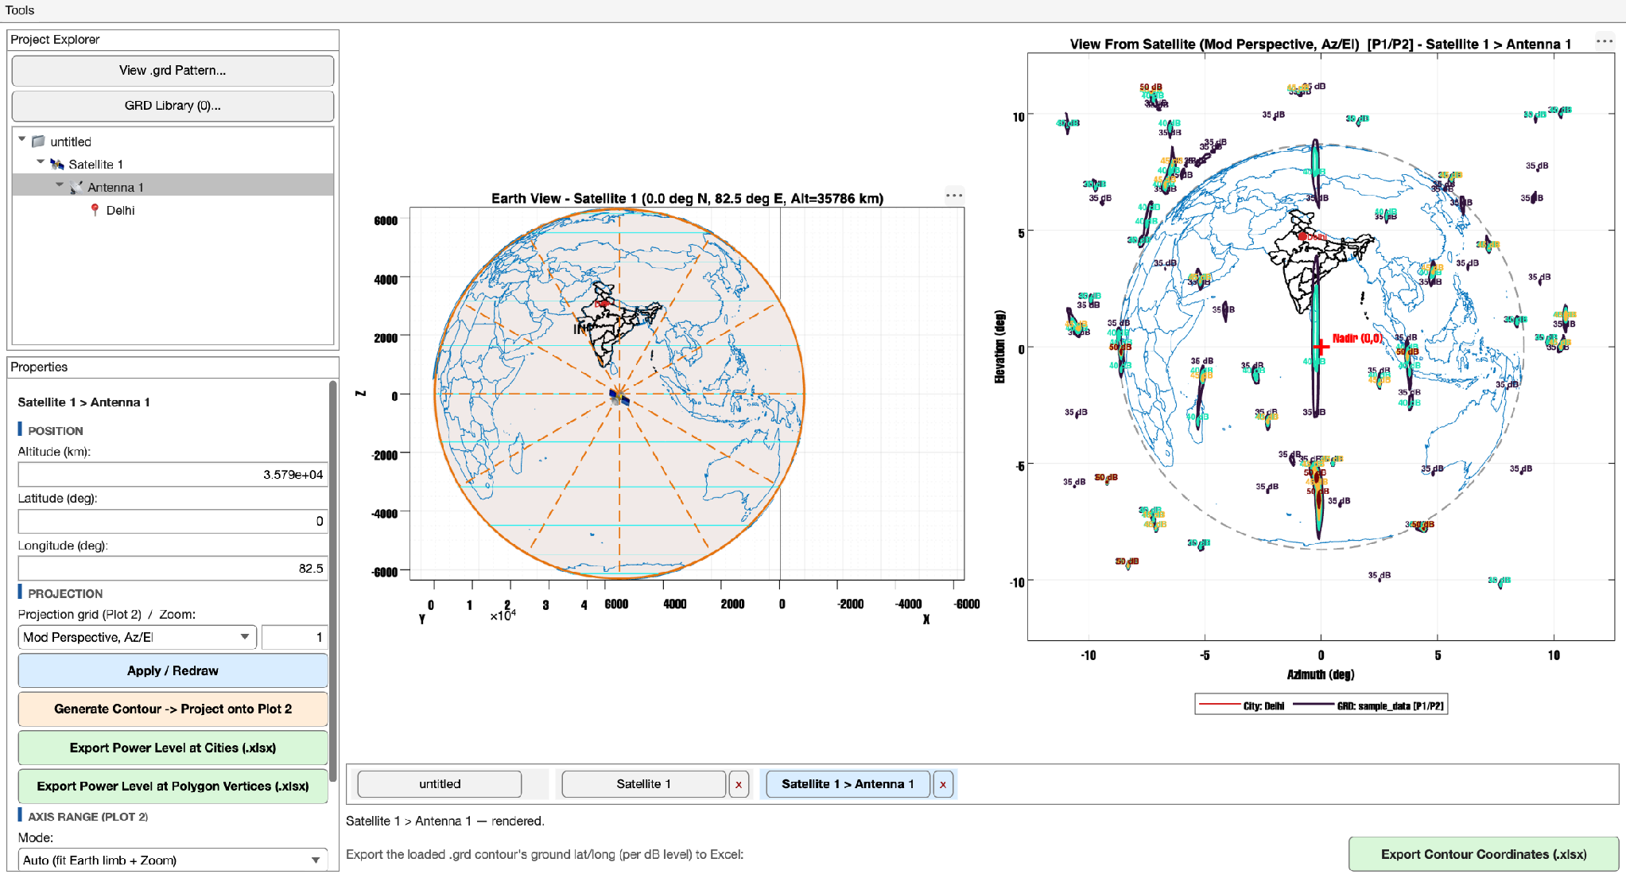
Switched to P1/P2, the co/cross discrimination ratio — note this occupies a completely different dB range from either P1 or P2 individually, typically tens of dB positive near boresight.
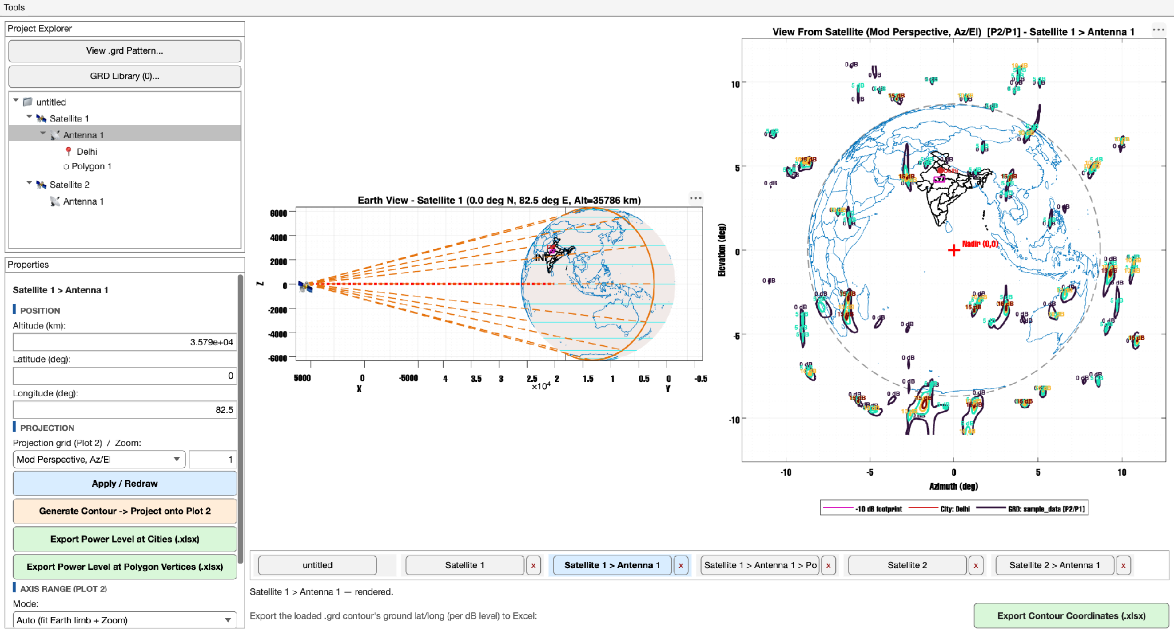
Switched to P2/P1, the exact mirror image of P1/P2 — the same discrimination information, expressed as a negative-valued ratio instead.

10.3 Ratio modes and Normalization
Because P1/P2 and P2/P1 are already absolute physical dB quantities in their own right rather than values measured relative to some peak, they are never shifted by Normalization or by the Peak (dB) field at all — and to prevent any confusion on this point, the Normalization dropdown and the Peak (dB) numeric field are both automatically greyed out and disabled inside the Contour Levels & Colors editor (Section 9) the moment either ratio mode is selected there.

10.4 Independent levels/colors per Polarization mode
Each of the four Polarization modes maintains its own fully independent set of dB contour levels and colors, on a per-Antenna basis — switching which Polarization view is currently displayed for a given antenna never loses, overwrites, or bleeds into whatever levels and colors you had previously configured for that same antenna's other three modes. The very first time you view a mode you have not yet manually customized for a given antenna, the application computes and shows a sensible default rather than an empty or nonsensical table: the P1 default comes from the GRD Library's own shared default for that file, while each of P2, P1/P2, and P2/P1 instead computes its own default anchored to THAT specific mode's own actual dB range — which matters a great deal in practice, since a co-polarization pattern's natural range (0 down to some negative floor) looks nothing like a positive-valued discrimination ratio's natural range, and silently reusing the P1 default for a ratio view would very often produce a contour search that finds nothing at all to draw.

11. Normalization & Peak (dB)
Normalization and Peak (dB) together control only HOW a given contour level's number is labeled on screen and written into exports — they never influence WHERE that contour is physically found on the underlying gain pattern, which, as established in Section 9, is always determined purely by the typed offset from the pattern's own peak, independent of Normalization mode entirely. In Relative mode, the default, every level is shown and exported exactly as typed, with the pattern's own peak always treated as 0 dB. In Absolute mode, every level is instead shown and exported as Peak (dB) plus the typed offset — for example, with Peak (dB) set to 40 and a typed level of -1, the shown/exported value becomes 39.
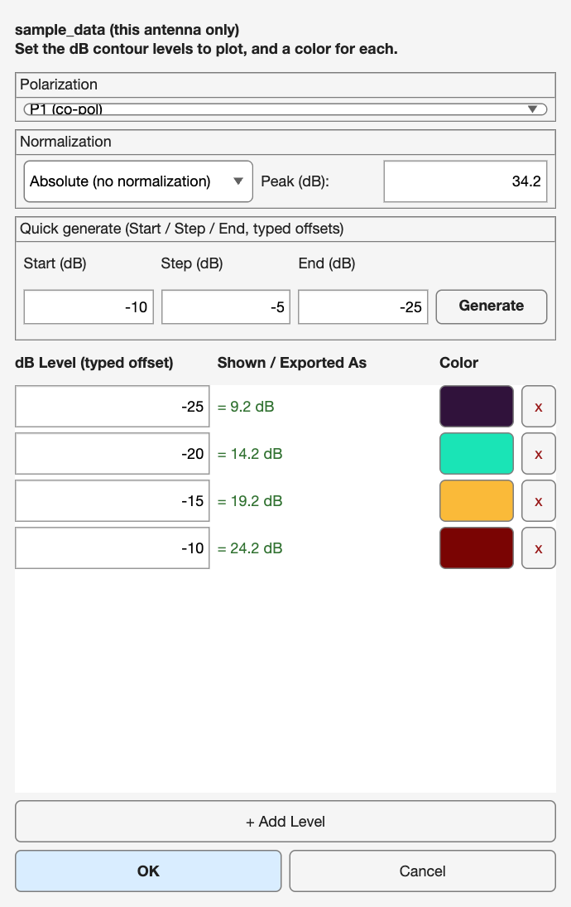
The same editor with Absolute normalization selected and a real Peak (dB) of 34.2 typed in — the "Shown / Exported As" column now diverges meaningfully from the typed offsets.
Peak (dB) is a freely, individually editable value maintained per Antenna, initially seeded from the .grd file's own auto-detected peak amplitude — which, for the great majority of exported pattern files, works out to approximately 0 dB, since most .grd exports are peak-normalized to unity amplitude by the simulation or measurement software that produced them in the first place. To make Absolute mode diverge meaningfully from Relative mode, type in the antenna's actual, real-world peak gain figure — for instance, 40 for a genuinely 40 dBi antenna — and Absolute-mode labels will then correctly reflect true, real, physical gain values rather than merely offsets from an arbitrary normalized peak. Both Normalization and Peak (dB) are edited directly inside the Contour Levels & Colors dialog covered in Section 9, rather than in the main Properties panel, since they are conceptually tied to how a specific set of levels gets labeled rather than being a general antenna-position setting.

12. Adjust Boresight
Right-clicking Plot 2 and choosing "Adjust Boresight..." shifts and rotates ONLY the selected antenna's .grd pattern OVERLAY as drawn on Plot 2 — the world and India country/state outlines, the dashed Earth-limb circle, and every ground footprint Polygon remain completely fixed in place and are entirely unaffected by this setting. The mental model worth holding onto is that of sliding a printed decal around on top of an otherwise fixed background image, rather than physically re-pointing anything in true three-dimensional space.
There is exactly one deliberate exception to that rule, and it is important enough to call out on its own: the "Export Contour Coordinates (.xlsx)" function documented in Section 18.1 DOES treat these same Az/El/Rotation values as a genuine three-dimensional re-pointing of the antenna's real physical boresight direction, using the actual rotation mathematics implemented in a dedicated function for exactly that export path. That means the ground latitude/longitude values written into that specific export correctly reflect where the antenna would truly, physically be looking after applying these offsets — even though the same offsets only ever produce a flat, cosmetic, 2-D shift when you look at Plot 2 with your own eyes.
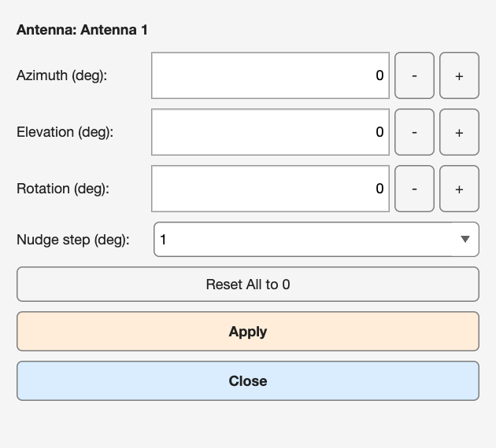
The Adjust Boresight popup — Azimuth/Elevation/Rotation fields, +/- nudge buttons, a configurable nudge step, and a Reset All to 0 shortcut.
Typing a value directly into one of the three fields and pressing Enter only edits the number sitting in that field — it deliberately does not apply or redraw anything by itself. You must click the Apply button (or use one of the +/- nudge buttons instead, since each individual nudge-button click is already treated as a single deliberate step and applies immediately) to actually move the pattern overlay and see the change reflected on Plot 2.

13. Peak Number Markers
Right-clicking Plot 2 and choosing "Peak Number" marks the single strongest point, or the several strongest distinct points, of whichever Polarization view is currently being displayed, directly on top of the plot itself, so you never have to hunt visually through a crowded set of contour lines just to answer "where exactly is this pattern strongest, and by how much."
Mode | What is drawn
None (default) | Nothing — no peak marker of any kind is drawn.
+ (symbol only) | A plain "+" symbol at the single strongest point on the currently-displayed pattern, with no accompanying text label.
+ Peak Number | The same "+" symbol, plus its absolute Peak (dB) value printed alongside it.
+ Peak (Top 3) | Up to three distinct, angularly-separated local maxima — deliberately spaced apart so the algorithm never reports three neighboring grid points off the same single lobe as three "separate" peaks — each individually "+"-marked and labeled with a rank of #1 through #3.
Every peak marker's printed number always shows the ABSOLUTE Peak (dB) value, deliberately regardless of whatever Normalization mode happens to be currently selected for that antenna. This is a deliberate design choice rather than an oversight: a Relative-mode number evaluated exactly AT the peak itself is, by the very definition of Relative mode, always going to read exactly 0 dB — which is trivially true and therefore useless information to display on a marker specifically meant to answer "how strong is this pattern, really?" The absolute value is what actually answers that question meaningfully.
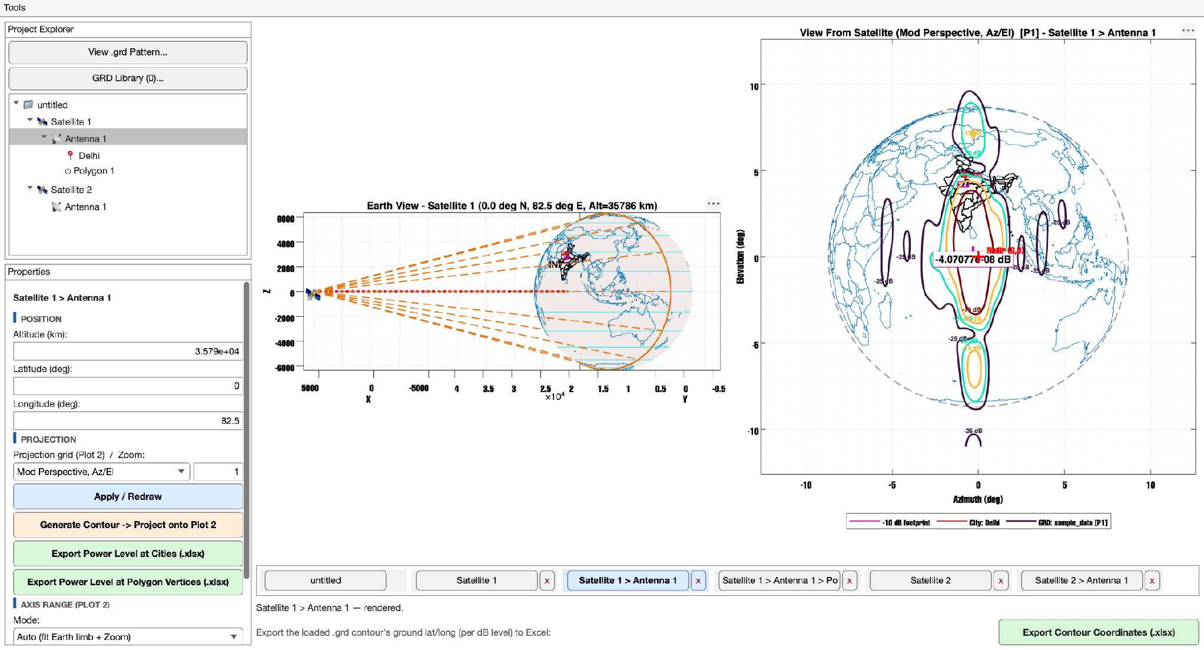
"+ Peak Number" mode — the single strongest point, labeled with its absolute Peak (dB) value.
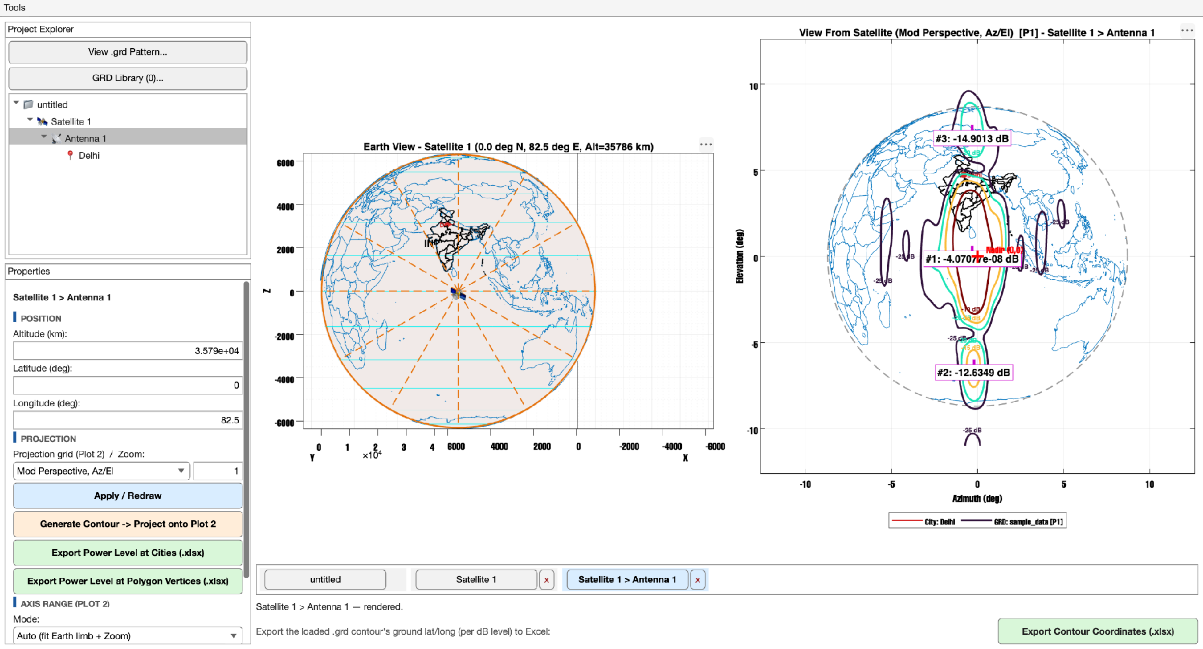
"+ Peak (Top 3)" markers shown on a P1 co-polarization pattern — three separate, angularly-distinct local maxima, individually ranked and labeled.

14. City Points
Right-clicking any Antenna node in the tree offers two distinct ways to add a City Point underneath it, covering both the "I know exactly where I want it" case and the "just give me a reasonable well-known Indian city to start from" case. "New City Point" adds a city at the antenna's own current position, with a generic default name and designation — you then type in the real latitude/longitude you actually want afterward via the Properties panel described in Section 4.4. "New City Point (From List)..." instead opens a State -> City picker window, pre-populated with every Indian state's capital plus four other well-known cities per state (roughly 147 entries in total), complete with a live search box.
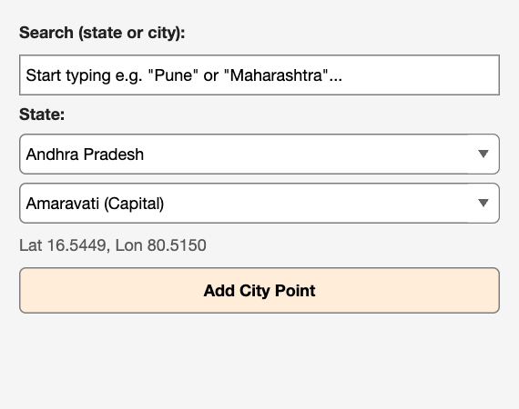
"New City Point (From List)..." — type a city or state name directly into Search to jump both dropdowns straight to the matching entry.
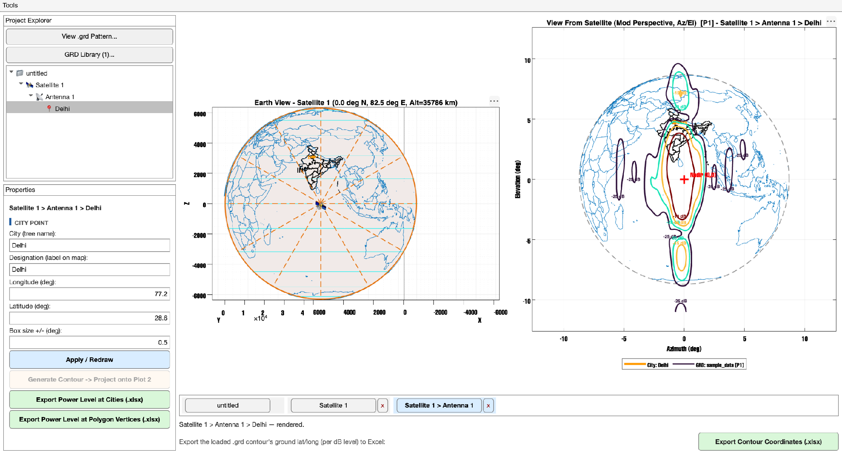
"Delhi" added under Antenna 1 — visible simultaneously in the tree, on the globe (Plot 1), and against the pattern contour (Plot 2, orange outline).
A City Point's "Box size +/-" field, described in Section 4.4, controls only the size of its small square marker box as drawn on Plot 1 — it has absolutely no bearing on Plot 2's appearance, and no bearing on the numeric result of either the contour-coordinate export or the power-level-at-cities export; it exists purely to make a city's marker easier or harder to spot visually on a crowded globe.

15. Footprint Polygons
Right-clicking an Antenna and choosing "New Polygon" adds a new, initially empty footprint Polygon underneath it. You then populate its vertex list — one latitude/longitude pair per line, in whatever order traces out the boundary you intend — directly inside the Properties panel described in Section 4.3, and click Apply to commit it. Every Polygon belonging to the currently selected Antenna is drawn together, simultaneously, on both plots: on Plot 1 at its true projected latitude/longitude position directly on the ellipsoid surface, and on Plot 2 likewise at its true projected position, since ground footprint Polygons — unlike the .grd pattern overlay itself — are never affected by the Adjust Boresight setting described in Section 12, and are always shown exactly where they geographically, physically sit.
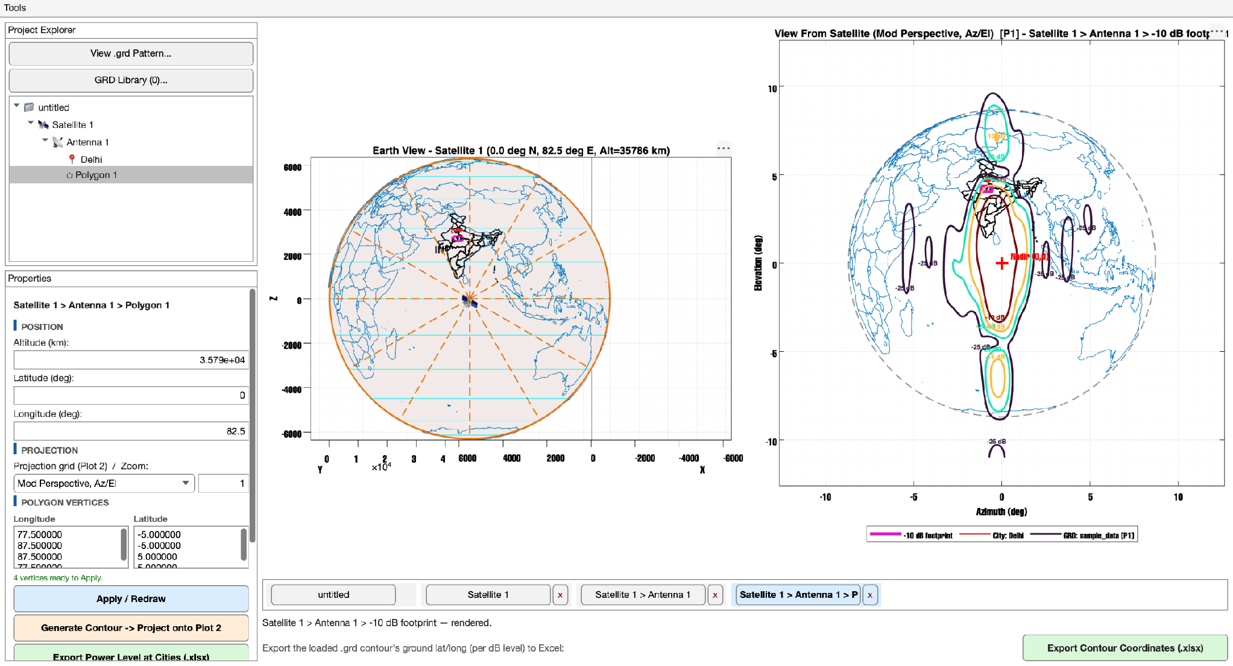
A footprint Polygon added and drawn on both plots simultaneously, alongside the antenna's own .grd contour lines.
If a Polygon's Name field contains a recognizable dB value — for example a name like "-10 dB footprint" — it is automatically color-matched against, and sorted alongside, the antenna's own contour-level colors on both plots, so a set of polygons representing several different service-area boundaries at different guaranteed power levels will naturally line up visually with the corresponding contour lines they are meant to represent.

16. Axis Range (Plot 2)
By default, in Auto mode, Plot 2 continuously auto-frames itself around the visible Earth limb, further scaled by whatever Zoom value is currently set for that antenna. Manual mode instead uses four typed X/Y minimum and maximum values as Plot 2's axis limits directly, completely independent of both Zoom and the Earth-limb framing calculation. Like Zoom itself, this is purely a per-antenna DISPLAY setting — it never touches contour-finding math, underlying geometry, or any of the three .xlsx export functions in Section 18, all of which continue to operate on the full, true pattern data regardless of how tightly or loosely Plot 2 happens to be framed at the moment.
This same underlying setting can be edited from either of two equivalent locations: the left panel's "AXIS RANGE (PLOT 2)" section (Section 4.2), or by right-clicking Plot 2 and choosing "Set Axis Range (This Antenna)...":
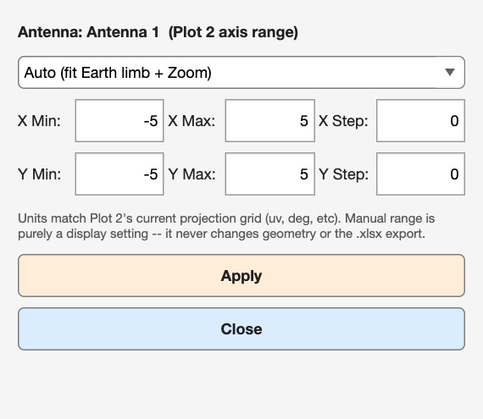
The Set Axis Range popup — units automatically match whichever projection grid is currently active for Plot 2 (uv, degrees, etc).
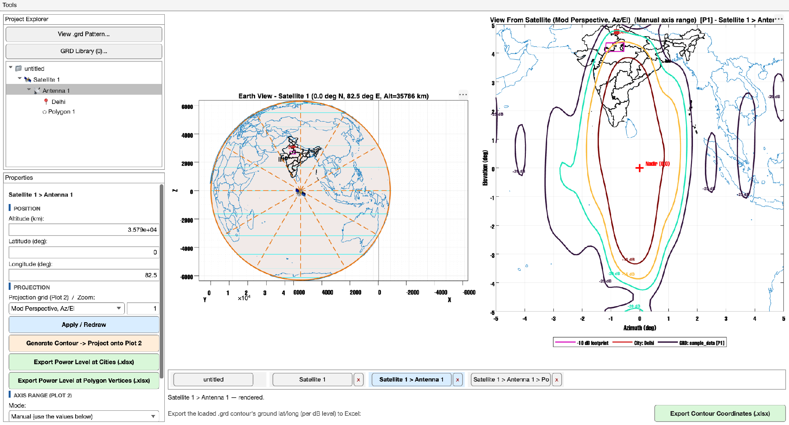
Plot 2 manually framed to a tight -5 to 5 degree box around nadir, using Manual axis-range mode.
The X Step and Y Step fields (a value of 0 means "let MATLAB choose gridline spacing automatically") control only the gridline and tick-mark spacing shown while in Manual mode — a purely cosmetic readability aid for when you have manually zoomed in tight around a specific small region and want evenly spaced, round-numbered gridlines rather than whatever spacing MATLAB's automatic tick placement would otherwise choose for that particular range.

17. The Tabs Strip
Every distinct node you select over the course of a session automatically earns its own tab along the bottom of the window, labeled with that node's full tree breadcrumb — for example "Satellite 1 > Antenna 1" — so that you can jump straight back to any previously visited node with a single click, without needing to re-navigate down through the Project Explorer tree to find it again. Click any tab to make it the active selection, exactly as if you had clicked that same node in the tree itself; click the small "x" on a tab to close it and remove it from the strip (the root "untitled" tab is a permanent fixture and cannot be closed, since it always represents the top of the whole project). If a node is deleted from the tree while its tab still exists, that tab is automatically and silently purged from the strip the next time the tree changes, so the tab strip never accumulates stale references to nodes that no longer exist in the project.

18. Exporting Results
Three distinct export buttons are available, and despite all three producing a similar-looking .xlsx workbook as their output, each one is carefully designed to answer a genuinely different underlying question about the currently selected antenna — understanding which question each one answers is the key to picking the right one for a given task, covered explicitly in the callout box at the end of this section.

18.1 Export Contour Coordinates (.xlsx) — bottom bar
This export answers the question "where does this antenna pattern REALLY, physically point on the surface of the Earth?" For every single point along every plotted dB-level contour line, it ray-casts the antenna's genuine three-dimensional boresight direction — including Az/El/Rotation applied as a true 3-D re-pointing, exactly as described in Section 12 — through the real WGS-84 ellipsoid Earth model from Section 5.4, and writes the resulting real ground latitude and longitude into the workbook, with one worksheet generated per distinct dB level.

18.1.1 THE RAY/ELLIPSOID INTERSECTION MATHEMATICS
The antenna look-direction is expressed as a parametric ray starting at the antenna's own 3-D position P and running in unit direction d:
$Ray(t) = P + t·d , t ≥ 0$
while the WGS-84 ellipsoid's surface itself is expressed by its standard implicit equation, using the same equatorial radius Re and polar radius Rp introduced in Section 5.4:
$\frac{x^{2}}{{Re}^{2}} + \frac{y^{2}}{{Re}^{2}} + \frac{z^{2}}{{Rp}^{2}} = 1$
Substituting the ray equation into the ellipsoid equation and expanding produces a completely standard quadratic equation in the ray parameter t, of the form A·t² + B·t + C = 0, where the weighting terms wxy = 1/Re² and wz = 1/Rp² are used for the equatorial and polar directions respectively — notably, this is the ONE place in the entire application where the equatorial and polar radii are genuinely treated as two different numbers rather than being collapsed into a single shared radius, since finding the true intersection point requires respecting the ellipsoid's actual non-spherical shape directly:
$t = \frac{−B − \sqrt{B^{2} − 4AC}}{2A}$
The minus sign placed in front of the square root is what selects the NEAR intersection point specifically — the point where the ray first touches the Earth's surface, coming from the satellite's side — rather than the far intersection point, where the same ray would eventually exit the far side of the ellipsoid if it were allowed to continue. If a given look-direction misses the visible Earth disc entirely, which does genuinely happen for the outermost, most strongly negative-dB contour rings on unusually wide antenna patterns, the discriminant B² − 4AC comes out negative, meaning there is no real-valued solution at all, and the export falls back instead to the single closest point on the Earth's surface to that particular look-ray, clearly flagged as such in the "OnEarth" column so every contour point still receives SOME usable coordinate rather than being silently skipped or left blank.
Column | Contents
Level_dB | The contour's dB level, passed through Normalization/Peak (dB) exactly the same way its on-screen label is computed.
ContourLine / PointIndex | Which specific contour loop this row belongs to, and which point's position along that loop.
Latitude_deg / Longitude_deg | The real computed ground position, rounded to three decimal places for a clean, consistent spreadsheet.
OnEarth | Reads "Yes" for a genuine ray intersection with the Earth; otherwise contains a note explaining that this row is the nearest-point fallback described above.

18.2 Export Power Level at Cities (.xlsx) — left panel
This export answers a deliberately different question from Section 18.1: not "where does the antenna physically point," but rather "what number does Plot 2 show ME, right now, at each of this antenna's City Points?" It reproduces the exact same on-screen display pipeline that Plot 2 itself uses internally, faithfully tracking Polarization, Normalization, Peak (dB), import Orientation, and Adjust Boresight exactly as they are currently set for the antenna, for every single City Point that currently sits underneath it in the tree.

18.3 Export Power Level at Polygon Vertices (.xlsx) — left panel
This export asks the exact same "what does Plot 2 currently show me here" question posed in Section 18.2, applied instead to every vertex of every footprint Polygon belonging to the selected antenna, rather than to City Points — producing one worksheet per Polygon, with one row per vertex, so a whole service-area boundary's worth of power-level readings can be reviewed or further processed at once.
Which export should I use? If your goal is to know where the antenna is genuinely, physically pointing on the real Earth — for a link budget calculation, for coverage verification against an authoritative map, or for any purpose where display-only settings like Orientation should NOT influence the answer — use Export Contour Coordinates. If your goal is instead to know exactly what number Plot 2 is currently showing you at one specific, already-known city or footprint vertex — matching the screen exactly, including any purely cosmetic Orientation or Adjust Boresight settings currently in effect — use one of the two Power Level exports instead.

19. Appendix — Full Right-Click Menu Reference

19.1 Root ("untitled")
- New Satellite

19.2 Satellite
- New Antenna
- Rename...
- Delete

19.3 Antenna
- New Polygon
- New City Point
- New City Point (From List)...
- Rename... / Delete

19.4 Polygon / City Point
- Rename... / Delete

19.5 Plot 2 (right-click the plot itself)
- Add GRD...
- Change Orientation...
- Edit Levels/Colors (This Antenna)...
- Polarization -> P1 / P2 / P1/P2 / P2/P1
- Peak Number -> None / + (symbol) / + Peak Number / + Peak (Top 3)
- Adjust Boresight...
- Set Axis Range (This Antenna)...

